Q1 | Deja Brew is a tea room based in Wetherby. The owner, Graham, is looking to expand the premises to increase the overall capacity. He has drawn up a network diagram, below, which shows the duration (in weeks) of all the activities.  Activity:  (A) Calculate the earliest start times/latest finish times for the network diagram below by completing all the nodes  (B) Identify the critical path  (C) Calculate the total float for activity E
Your workings:

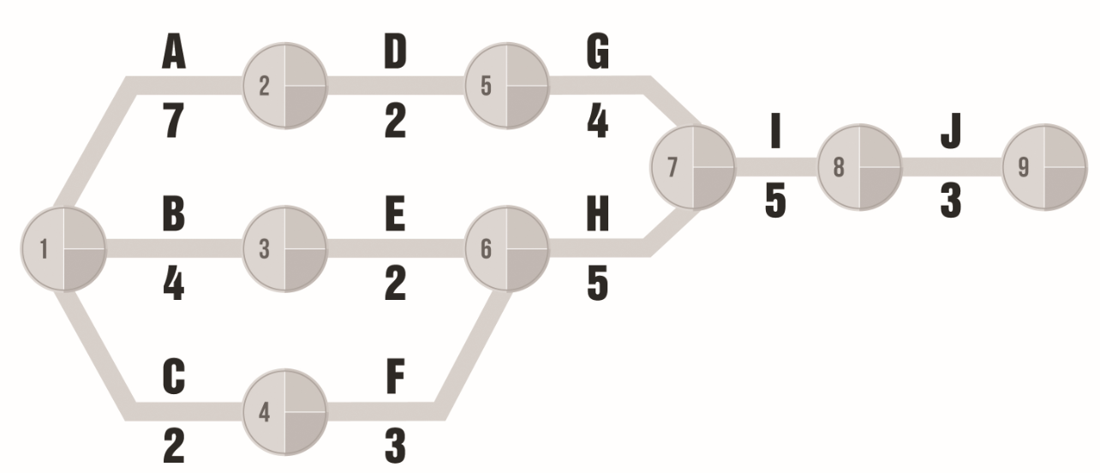

Q2 (a) | Glad Wags is a café with a difference. Catering for dog owners and their pets, this canine café has a “hounds and humans” menu. Due to the success of the business, the owner is planning to open up a second café and has begun constructing a network diagram which shows the estimated duration of each activity (in weeks).  Activity:  (A) Calculate the earliest start times/latest finish times for the network diagram below by completing all the nodes  (B) Identify the critical path  (C) Calculate the total float for activities C and E
Your workings:

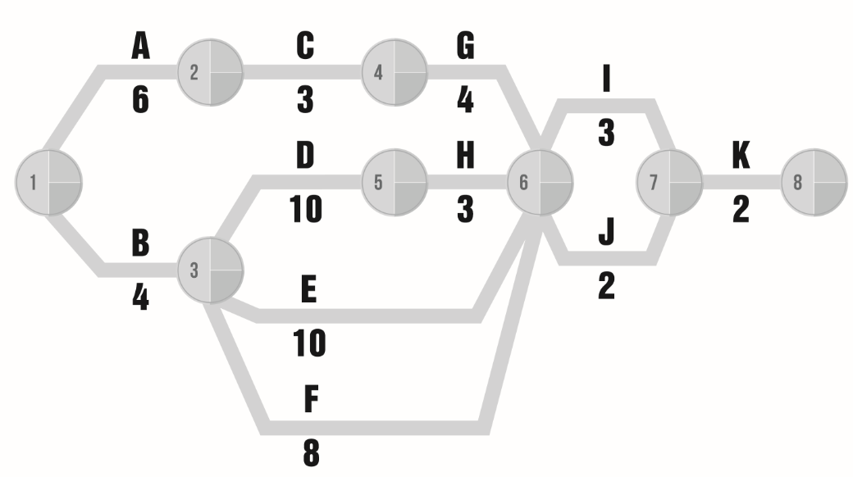

Q2 (b) | After completing the network diagram the owner believes that some of the durations are incorrect. The owner believes that:  - Activity A will take an extra 2 weeks  - Activity C will take an extra 3 weeks  - Activity G will now take 5 weeks  - Activity D will only take 8 weeks  Activity:  (A) Complete and amend the network diagram below to take into account the changes to the above activities (all other durations remain the same)  (B) Identify the new critical path
Your workings:

