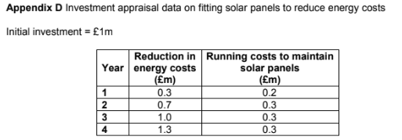
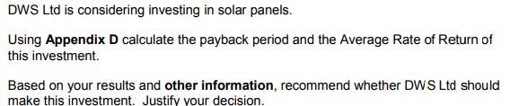
Calculations

They Should | They should not
Judgement

