[](https://www.google.co.uk/url?sa=i&rct=j&q=&esrc=s&source=images&cd=&cad=rja&uact=8&ved=0ahUKEwikpqj1sf3YAhXnCcAKHQWjAzsQjRwIBw&url=https://www.new-directions.co.uk/social-care/&psig=AOvVaw23RRzMUp0OCJFekijDssHk&ust=1517322060600239)[](http://www.google.co.uk/url?sa=i&rct=j&q=&esrc=s&source=images&cd=&cad=rja&uact=8&ved=0ahUKEwips97os_3YAhVMKsAKHVwWDPcQjRwIBw&url=http://www.uwtsd.ac.uk/msocstud-social-studies-health-social-care/&psig=AOvVaw2Z_RRgQeg36hN9n1wjrryA&ust=1517323259031237)**BTEC National Diploma**

**in Health and Social Care**

**What is health and social care?**

Health and social care is the study of people and their individual needs.

On this course you will study the different factors that affect an individual’s health and wellbeing.

You will also gain an understanding of the importance of care and how we support these individuals effectively.

**If you are a caring and compassionate person, who is interested in learning about the health and wellbeing of others then this is the ideal course for you.**

**Health and Social Care roles**

Often when people think about jobs within Health and Social Care they only think of either doctors, nurses, midwifes or social workers

There are however 100s of different jobs within this sector:

[](https://www.google.co.uk/url?sa=i&rct=j&q=&esrc=s&source=images&cd=&cad=rja&uact=8&ved=0ahUKEwia_pXAs_3YAhVKJcAKHYOpAb8QjRwIBw&url=https://www.calendar-boys.co.uk/images-before-and-after/&psig=AOvVaw22xuvq5Tkz8uULYkkCanLb&ust=1517323188154823)

[](http://www.google.co.uk/url?sa=i&rct=j&q=&esrc=s&source=images&cd=&cad=rja&uact=8&ved=0ahUKEwjT9Lfzsv3YAhUhD8AKHbv_B68QjRwIBw&url=http://abroadship.org/training-course-tictac-multilateral-training-course-support-quality-youth-worker-mobility-activities-erasmus-youth-action-bulgaria/&psig=AOvVaw3NWIhu0pimDgLGhB7Ma_Et&ust=1517323006885097)Police officers

Probation officer

Prison officer

Occupational health visitor

Support workers

Mental health support worker

[](https://www.google.co.uk/url?sa=i&rct=j&q=&esrc=s&source=images&cd=&ved=0ahUKEwjA0Y2Xsv3YAhWFW8AKHSZsARgQjRwIBw&url=https://www.professionalstandards.org.uk/&psig=AOvVaw23RRzMUp0OCJFekijDssHk&ust=1517322060600239)Teacher

Teaching Assistant

Child Minder

Radiographer

Paramedic

Dentists

ODP

[](http://www.google.co.uk/url?sa=i&rct=j&q=&esrc=s&source=images&cd=&cad=rja&uact=8&ved=0ahUKEwjjsNm-sv3YAhXKWsAKHZbnChUQjRwIBw&url=http://www.learndirect.com/catalogsearch/result/?q=functional&psig=AOvVaw23RRzMUp0OCJFekijDssHk&ust=1517322060600239)Youth Worker

[](http://www.google.co.uk/url?sa=i&rct=j&q=&esrc=s&source=images&cd=&cad=rja&uact=8&ved=0ahUKEwjckKyYs_3YAhWpC8AKHRrRC-cQjRwIBw&url=http://www.cloudaccountant.co.uk/blog/2016/02/childminder-v-nanny-tax&psig=AOvVaw0hkPp8cvQbaBV3bQpVCR2P&ust=1517323105515625)Youth Offending Officer

Psychologist

Counsellor

Therapist

Dietician

Physiotherapist

**BTEC Level 3 National Diploma in Health and Social Care**

**Course Structure**

|  |  |
| --- | --- |
| Y12 | Y13 |
| Unit 1- Human Life Span Development (1.5 hour EXAM) | Unit 4- Enquiries into Current Research in Health and Social Care (3 hour EXAM) |
| Unit 2- Working in Health and Social Care (1.5 hour EXAM) | Unit 8- Promoting Public Health (COURSEWORK) |
| Unit 5- Meeting Individual Care and Support Needs (COURSEWORK) | Unit 7- Principles of safe practice in Health and Social Care (COURSEWORK) |

**Unit 1- Human Lifespan Development**

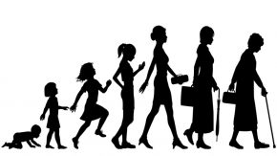This unit will develop your knowledge and understanding of patterns of human growth and development. You will explore the key aspects of growth and development, and the experience of health and wellbeing. You will learn about factors that can influence human growth, development and human health. Some of these are inherited and some are acquired through environmental, social or financial factors during our lifespan. You will learn about a number of theories and models to explain and interpret behaviour through the human lifespan. In this unit, you will explore the impact of both predictable and unpredictable life events and recognise how they impact on individuals. You will study the interaction between the physical and psychological factors of the ageing process, and how this affects confidence and self-esteem, which in turn may determine how individuals will view their remaining years

**Unit 2- Working in Health and Social Care**

When working for an organisation in this sector, you will have important responsibilities that you need to understand and carry out. You will begin by looking at the range of roles and general responsibilities of people who work in health and social care settings. You will learn about the organisations that provide services in this sector, and the different settings in which these services are delivered according to the needs of the service user. You will learn about the ways these services are provided and about the barriers that can prevent people from getting the services they need. As an employee of an organisation that provides services in the health and social care sector, you will have responsibilities towards people who seek information and advice, those who are being assessed and people who use services provided by or on behalf of your employer. You will also have responsibilities towards your employers, both as an employee and when you are undertaking specific duties on behalf of your employer. These organisations are regulated and inspected so you will also need to understand how inspectors and regulators monitor the work that you do.

**Unit 4- Enquiries into current research in Health and Social Care**

In this unit, you will find out about the different research methods that can be used to gather information and the ethical issues that need to be considered. You will review research carried out into a contemporary issue in the sector and will develop skills that will enable you to carry out your own secondary research into the issue. You will then consider how the research findings may benefit service users or improve practice and make recommendations for further research.

**Unit 5- Meeting individual care and support needs**

In this unit, you will learn about the values and principles of meeting care and support needs and look at some of the ethical issues that arise when personalising care. You will examine factors that can impact the professionals who provide the care and support, and the challenges that must be overcome to allow access to good quality care and health services. You will explore the different methods used by professionals across all care services. You will reflect on these methods when you consider the importance of multi-agency working in providing a package of care and support that meets all the needs of individuals.

**Unit 7- Principles of safe practice in health and social care**

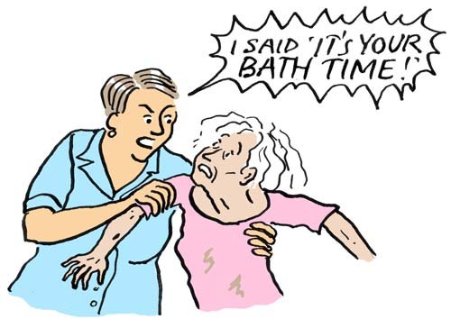This unit will develop your knowledge and understanding of the key principles relating to safeguarding vulnerable individuals, promoting health and safety, and responding to different situations and emergency incidents in health and social care settings. You will learn about the professional responsibilities for maintaining safe practice. You will explore the legal duty of care and the importance of legislation, policies and procedures in protecting individuals from harm, upholding their rights and promoting their welfare. You will examine the types of abuse and neglect that service users can experience and learn how to recognise and respond to concerns about abuse and neglect in health and social care settings.

**Unit 8- Promoting Public Health**

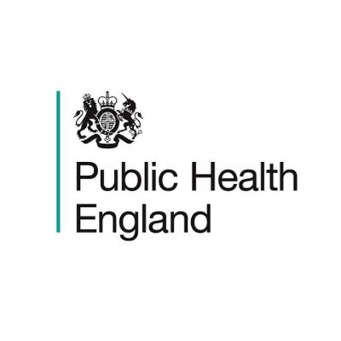This unit will give you an understanding of the aims of public health policy. You will explore how patterns of health and ill health of the population are monitored and how this leads to the development of public health policy. You will consider factors affecting health locally and nationally. You will consider different methods of promoting and protecting public health. You will develop an appreciation of the barriers to be overcome with promoting public health and ways of making people aware of public health issues. You will gain a greater understanding of how healthcare professionals and government agencies use public health initiatives to encourage individuals to change their behaviour in relation to their health.

**Unit 14- Physiological Disorders and their care**

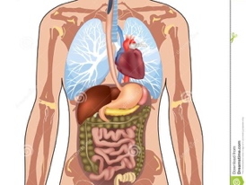In this unit, you will learn about the signs and symptoms of physiological disorders and how they are investigated and diagnosed. You will also learn about the different types of treatment and support available for individual service users, including surgery, rehabilitation and complementary therapies. You will create a treatment plan for a service user with a specific physiological disorder. This will help you understand the treatment and support strategies involved, the contributions of different professionals and the importance of providing individualised care.

**Unit 19- Nutritional Health**

In this unit, you will learn about the nutritional value of food and the dietary sources and function of different nutrients in the body. You will also learn about individual dietary needs, dietary recommendations and the factors that can influence nutritional health, such as lifestyle choices, education and culture. You will examine health factors that can affect nutrition, including medical conditions, digestive disorders, and food allergies and intolerances. Finally, you will develop practical skills in promoting nutritional health through the creation of a nutritional health improvement plan.