**Psychology Transition – Week 7 – Biopsychology**

This week we are going to look at a topic that you will study in depth in Y13 and a little bit in Y12. Biopsychology investigates how our biology influences the way we act. With a particular focus on how brain functioning affects the way we act. I have attached the specification for you to see below.

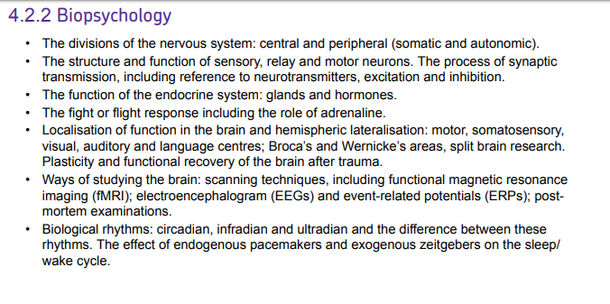

This week I would like you to watch the following documentary about the girl who had half a brain. When you first think about this concept you might think it is impossible for somebody to live with only half a brain- but the girl in this documentary suggests otherwise! I would like you to write down 10 facts that you learn from this documentary and ONE question you have for me that you would like answering.

<https://www.youtube.com/watch?v=0GXNouwaAlE>