**BTEC National Diploma in Health and Social Care**

**Y11 Transition Work- Week 1**

Hello and welcome to the first task for your transition to the BTEC National Diploma in Health and Social Care.

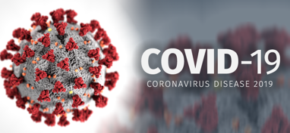

As you are all aware Covid- 19 is having a significant impact globally.

I am aware that you may be tired of hearing about this disease as it discussed constantly in the news / social media and is at the forefront of everyone’s mind. From a Health and Social Care perspective this is the most significant issue that has affected the sector since the first world war.

We have seen and experienced that life as we know it has changed and we have all had to adapt to these changes. This, however, is even more prevalent in the daily running of the Health and Social Care sector.

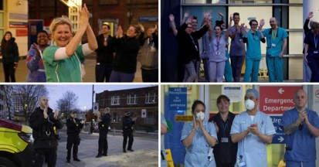At 8pm each Thursday evening millions of people gather on their doorsteps or balconies to clap and make as much noise as possible to show our appreciation for the NHS and Social Carers.

For some of you this pandemic may have strengthened your desire to work in this profession and for others it may have been something that you have never really thought about before. It is therefore extremely important that we begin to understand how Covid- 19 is affecting society and the impact that this will have in future on the Health and Social Care sector.

Some of the Government initiative so far include-

The Government have pledged £180 Billion to support Businesses, The NHS, Social Care, Charities, Education, Police and Welfare

Schools are closed

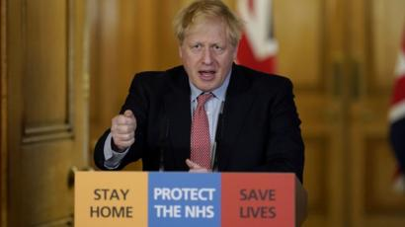Lockdown

6.3 million employees have been furloughed

35,000 retired medical staff and final year students have been employed

7 Nightingale Hospitals

Increased supply of Personal Protective Equipment- Trinity High School have made some of these

750,000 NHS Volunteers have been recruited

£750 million for charities

Your first transition task is focused on gaining an in-depth understanding of Covid- 19 and the affect this disease is having on UK citizens.

I would like you to watch the following documentaries:

Netflix- Coronavirus explained

You Tube- Documentary: Life in lockdown under coronavirus

<https://www.youtube.com/watch?v=9XrE41Wu3U0>

Write a report explaining the following-

* What is a pandemic?
* What is Covid- 19 and what are the main symptoms?
* What advice have we been asked to follow from the Government and Public Health England?
* How is Covid- 19 affecting the NHS? What measures have been implemented to support this? Is this support enough? What else do you think could be done?
* How is Covid- 19 affecting the Social Care Sector (Care Homes, Home Care, Charities etc) What measures have been implemented to support this? Is this support enough? What else do you think could be done?
* How has your life changed due to Covid-19, what are you doing differently and how are coping with these changes on a daily basis?