Psychology Transition Work – Week 4 – Memory

One of the topics that you will study in Y12 is Memory. You will investigate how memories are stored, why we forget things and then how we can use research about memory to inform real life practices such as Eye Witness Testimony. I have included the spec below. As always feel free to research any part and let me know what you find!

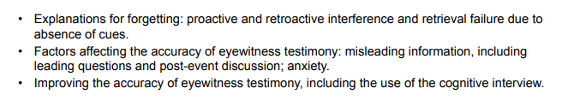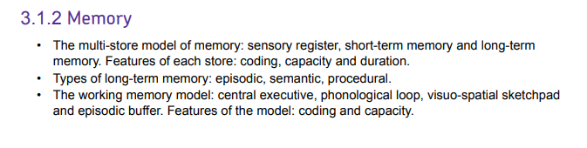

This week I would like you to create a fact file on one of the most influential psychologists in the field of memory; Elizabeth Loftus. Elizabeth Loftus research focuses on the creation of false memories, we can implant and alter people’s memories so that they can remember things that never actually happened! This is very important when it comes to interviewing witnesses to a crime- you do not want them to give any false information because you have caused them to misremember the crime.

Using the following resources I would like you to create a detailed fact file about the life and work of Elizabeth Loftus. You should include her education and any influential research she has conducted- she has given many speeches which you can find on youtube! Please also include anything that you found particularly interesting!

Resources:

Mind Changers – 17th April 2011- Elizabeth Loftus and EWT, you can access this by downloading the BBC sounds app and searching for mind changers in their podcast section. You can also access this via the BBC website.

<https://www.youtube.com/watch?v=FMkZWXDulA4> (an example of one of the many youtube documentaries she has done)

<https://www.simplypsychology.org/loftus-palmer.html>

There are lots and lots of websites about her if you google her name!