**Criminology Transition work**

**Week 2**

I hope you enjoyed week one, especially getting right in to some of the debatable topics. We will be doing a lot of debating over the 2 years in criminology so it is really important to get into it from the start. You have to open your mind and really think about things from various points of view.

Activity 1

Criminal Case Studies

This week I want us to start developing our knowledge of a range of crimes.

It is quite important to really read into what people have done because that will give you a really good foundation on your knowledge of crime and help you explain theory. I will give you a list of offenders and victims and you need to explain what happened and go through as many of the questions above as you can.

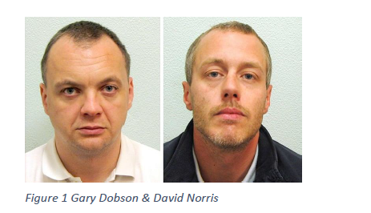Here are some to try this week

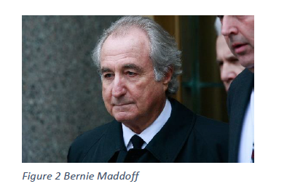

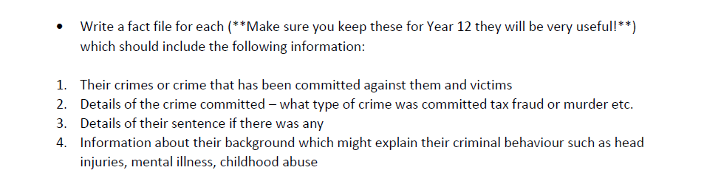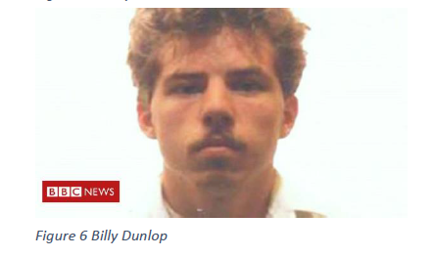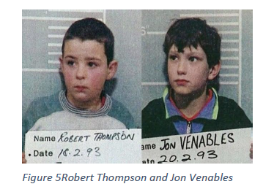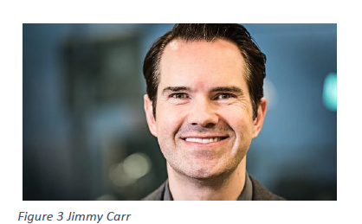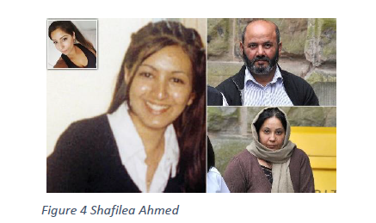

Activity 2

I want you to watch this documentary on Jack the Ripper and answer the following questions.

<https://www.bbc.co.uk/iplayer/episode/m0003wdk/jack-the-ripper-the-case-reopened>

Why was the killer never caught originally?

What is geographical profiling and how might it have helped?

What is HOLMES and would this have helped?