**Criminology Transition Work**

**Week 1**

**Welcome to Applied Criminology**

You have chosen a subject that combines elements of psychology, law and sociology and that complements studies in humanities. Each unit has an applied purpose which demands that learning is related to authentic case studies – this is the interesting bit! It will certainly ‘keep you on your toes’ and make you think in ways you couldn’t imagine. You will certainly have a very different outlook on society by the end of your course.

**Overview of the course:**

This is a two-year course. Units 1 and 2 completed in the first year comprise an 8-hour Controlled Assessment plus a formal examination. This is replicated in Year 2 with Units 3 and 4. You must **complete and pass ALL units** to gain the Diploma. The overall grades will be recorded on a scale A*-E.

Unit 1: Changing Awareness of Crime (Controlled Assessment)

Unit 2: Criminological Theories (Exam)

Unit 3: Crime Scene to Courtroom (Controlled Assessment)

Unit 4: Crime and Punishment (Exam)

Look at the specification for more detail about these topics. You can find this at: <https://www.wjec.co.uk/media/21xjkr24/applied-diploma-in-criminology-specification-from-2015.pdf>

You will be expected to **know and understand** the information covered, to be able to **apply** that knowledge and understanding and to be able to **analyse and evaluate** that knowledge and understanding.

***Task 1***

Read the specification carefully and make a note below of the sections there are to each Unit:

Changing Awareness of Crime…………………………………………………………..

.………………………………………………………………………………….………………

………………………………………………………………….............................................

Criminological Theories…………………………..………………………………………...

…………………………………………………………………………………………………..

…………………………………………………………………...……………………………..

Crime Scene to Courtroom………………………………………………………………..

…………………………………………………………………………………………………..

…………………………………………………………………………………………………..

Crime and Punishment in Society………………………………………………………..

………………………………………………………………………………………………….

…………………………………………………………………..………………………………

Task 2 Criminal Behaviour

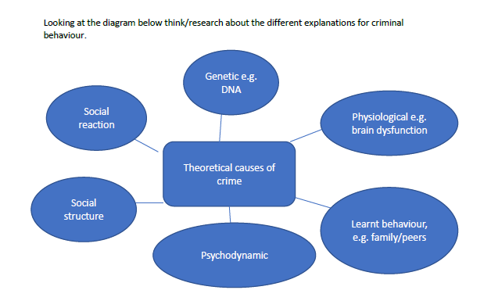

What I want you to do is have a look in to each of these potential causes of crime. I want you to write a short paragraph on each explaining what they mean.

Then I want you to order them 1-6 most influential to least influential and write why you have chosen this particular order. You can look back on this at the end of the unit and see if any of the order has changed for you.

­Task 3

Can someone be born a criminal?

This is an interesting question and looks at what we call the nature/nurture debate. Are criminals genetically made to be a criminal or are they created by their environment and upbringing?

Read this article

<https://www.bbc.co.uk/news/magazine-31714853>

Try and answer the question: are criminals born to be criminals or are they made by their environment?