Dear Year 11

Thanks for choosing to study A level English Literature.

The essential requirements are an appetite for reading plays, poems, novels and critical essays and a willingness to study independently from lessons for 3-4 hours per week.

TRANSITION WORK WEEK 1

This week you will be looking at modern poetry. We want you to engage with some poems from your prescribed anthology of poetry called: Poems of the Decade

Task 1: you will need to follow the link and log in to the following website.

You need to enter the English and Media E-magazine online with the following details: <https://www.englishandmedia.co.uk/e-magazine/emag-login/>

Username: cvh5 Password: English

When you are in, type: *Poems of the Decade* in the Search box 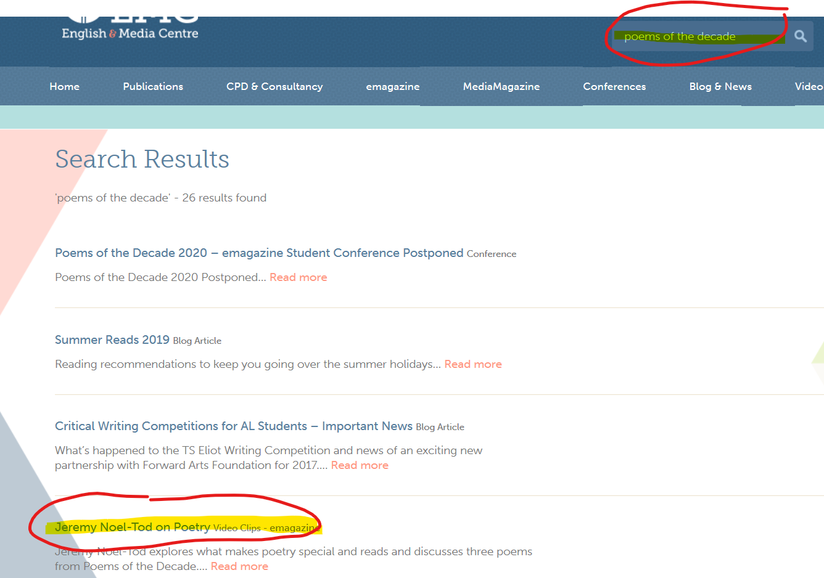

And find the article called Jeremy Noel-Tod on Poetry.

Click on it and watch the following videos. 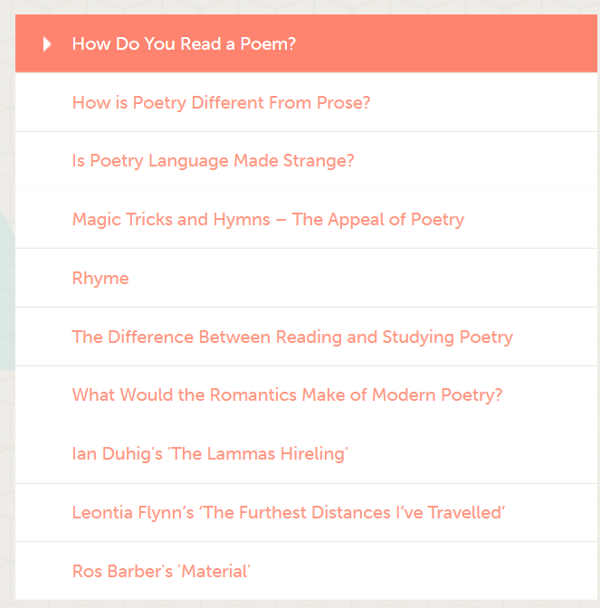

The first 7 are about poetry in general and the next three are about three poems from the anthology.

Task 2:

1. watch the first 7 video clips
2. make notes /mind maps on the key points Jeremy Noel-Tod’s raises in each video
3. watch the remaining three videos and explain what you think you have learnt about the three poems.

This can be submitted in the form of a word document, pdf or images of your work.

(Please retain copies of your work)

Enjoy! Mr Cornick and Mrs Parker