Product. **Bike Brake ( Materials, Components and Processes)**

**Front Brake Assembly**

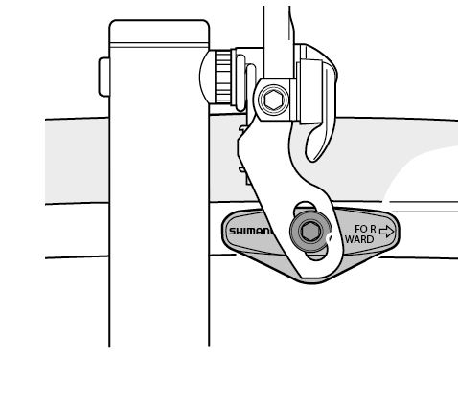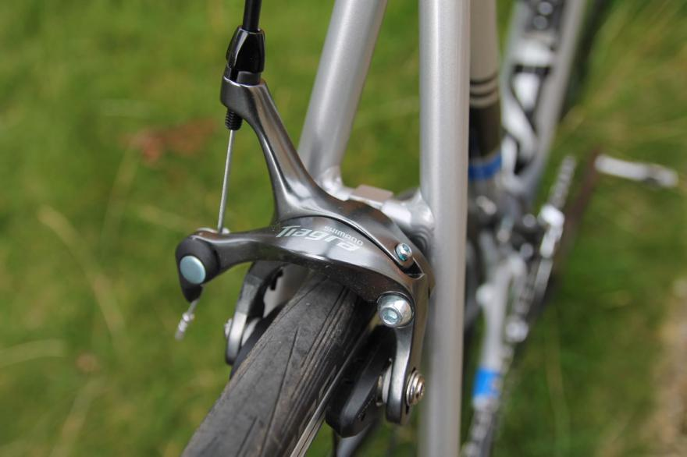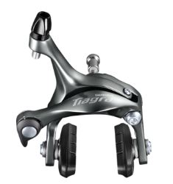

**Part A.**

**Labelled Brake System *Label all the parts on the two drawings.***

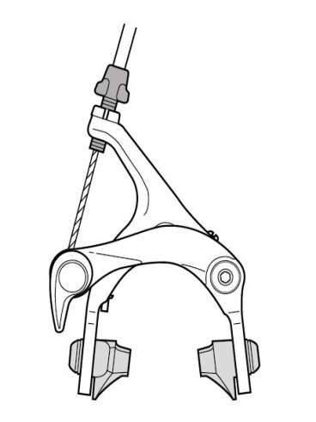

**Labelled Exploded Assembly Drawing. *Label all the parts on the two drawings.***

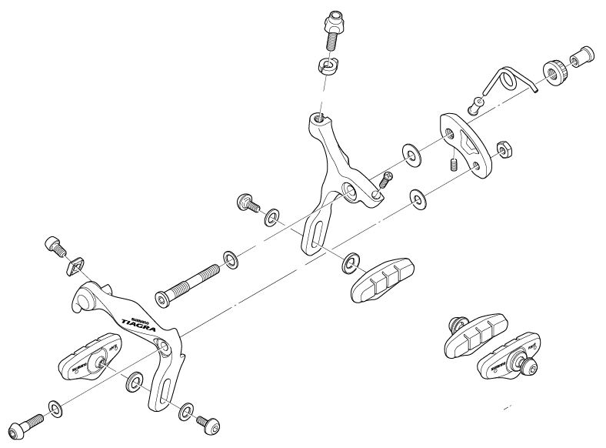

**Part A.**

**Section I, II and III. *Textbook page 78 to 101.***

**Parts List , Type/Characteristic, Material.**

|  |  |  |
| --- | --- | --- |
| Part Name | Proprietary/Specific | Material |
|  |  |  |
|  |  |  |
|  |  |  |
|  |  |  |
|  |  |  |
|  |  |  |
|  |  |  |
|  |  |  |
|  |  |  |
|  |  |  |
|  |  |  |
|  |  |  |
|  |  |  |
|  |  |  |

**Part B.**

**Section I. Proprietary Components Details**

***L2P – Describe engineering materials and proprietary components used in given engineered products.***

**Screws.**

***You must explain what each type of proprietary component does in the brake. The function and how it is achieved.***

***You should comment of the characteristics such as size/ dimensions, permanent or semi permanent, surface features and finishes.***

***You should comment on the availability of such components. Where can they be bought from and how much. Give examples from grabs of websites such as SCREWFIX.***

***Repeat for following and any others you can identify.***

**Bolts**

**Washers**

**Brake Block?**

**Section II. Materials / Properties**

There are *?* different materials used in the bike brake

1. Stainless Steel. Ferrous. *Name all of your materials and its category (eg .Non-Ferrous)*
2. ???????????
3. ???????????

**Stainless Steel**

***For each material you must give the properties of the materials used and how these properties influenced the choice of that material in this particular product. Properties cover strength, hardness and toughness.***

***You should mention the Charateristics and include machinability, workability and durability.***

***Give examples of products made using each material and give reasons why it is used. You are allowed to show photographs as long as you reference the source.***

***What aspects of the intended use of the bike brake justify each material. This could be weight, corrosion resistence, wear resistance, workability. Give reasons.***

***Evaluate the materials use in the brake. Is it effective and meet the requirements of the product. Is it effective in terms of ease of manufacture and cost.***

***Finally is there an alternative material that could be used? Give reasons and complete a comparision.***

***Remember***

***L1P – Identify Engineering Materials***

***L1M- Describe Engineering Material***

***L2P- Describe Engineering Materials Used in the Brake***

***L2M1- Explain why the materials are used in the Brake***

***L3D-Evaluate the use of the material. This could mean offering alternative materials and discussing.***

***Repeat this process for all your materials.***

**Section III. Making Processes for the Product Specific Components.**

***L2P -Describe engineering processes used to make given engineered products.***

***L2M2 - Explain why engineering processes are used to make given engineered products.***

***L2D - Evaluate engineering materials, proprietary components and processes used when making given engineered products.***

**Die Casting (Main Brake Arms)**

***Describe the process using images and words. Explain why this process has been used to make this particular component. What is it about the component that makes this process the most suitable. This could be speed, accuracy, repeatability, initial investment cost etc etc. Give advantages and disadvantages of the process.***

***Explain why the material used in the brake is suitable for this process.***

**Drilling and Milling (Main Brake Arms)**

**Injection Moulding (Brakes Shoes, Cable adjustment arm, Return spring sleev and Barrel Adjuster Washer)**

**Shearing, Forging and Thread cutting (Barrel Adjuster, Cable Holder)**

**Bending and Coiling (Return Spring)**