**Sociology Transition Work**

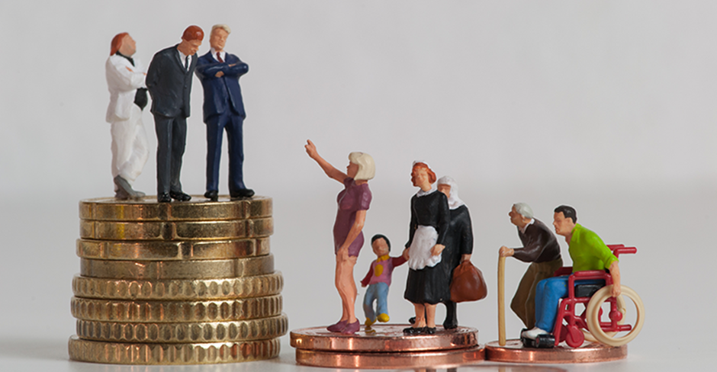

**Key questions in sociology: is modern British society fair?**

* Is the education system fair?
* Is the family fair?
* Is the criminal justice system fair?

Is modern British society fair?

**Over the next few weeks we are going to explore some of the big questions in sociology:**

* Is the education system fair?
* Is the family fair?
* Is the criminal justice system fair?

**Key question: is Britain fair?**

**Two babies are born on the same place. Do they have an equal chance of…**

… being healthy?

… going to university?

… getting a well-paid job?

… avoiding prison?

… succeeding in school?

**The stats**

* One third (30%) of children in Britain live in poverty
* People born into the most deprived (poor) areas of the UK are likely to live, on average, 10 years less than those in affluent (well off) areas
* Only 30% of those receiving Free School Meals (FSM) (low family income) achieve a pass in English and Maths at GCSE compared to 60% of those who do not receive FSM
* Only 7% of the population go to fee-paying schools, but they make up 42% of students at Oxford and Cambridge and dominate top jobs in law, journalism, politics and health
* Last year, there was a 13% increase in food bank use

These statistics paint a bleak picture of whether or not Britain is a fair society. Before we engage in the debate of whether or not Britain is fair, we must define what we mean by this.

In Sociology, a ‘fair’ society is a society where everyone has equality of opportunity – everyone has an equal chance of achieving success and their background does not determine this. Sociologists call this a ‘meritocracy’ – a society where status is based on merit (hard work and talent) rather than the position you are born into. In a meritocracy, effort should be the only factor determining the position someone gains in life.

**Functionalists believe contemporary (modern) Britain is a meritocracy and that success is determined only by hard work.**

**Quick check: look at the following cartoons and reflect on the statistics above. In your opinion, does everyone have an equal chance to succeed? Why or why not? Write your response in the box provided.**

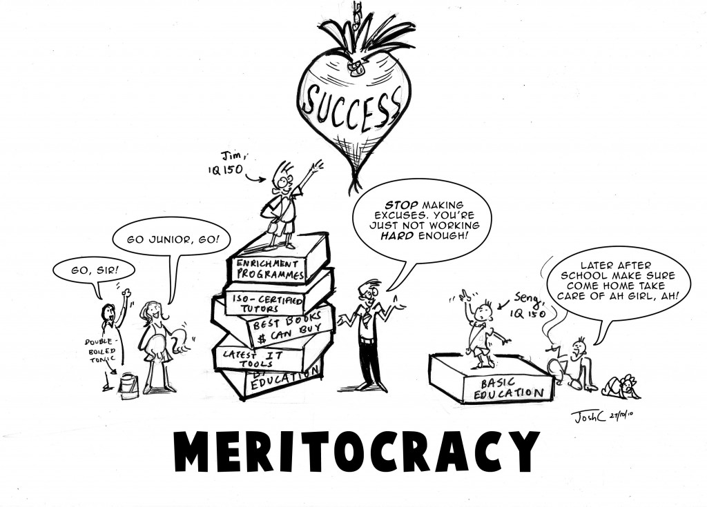

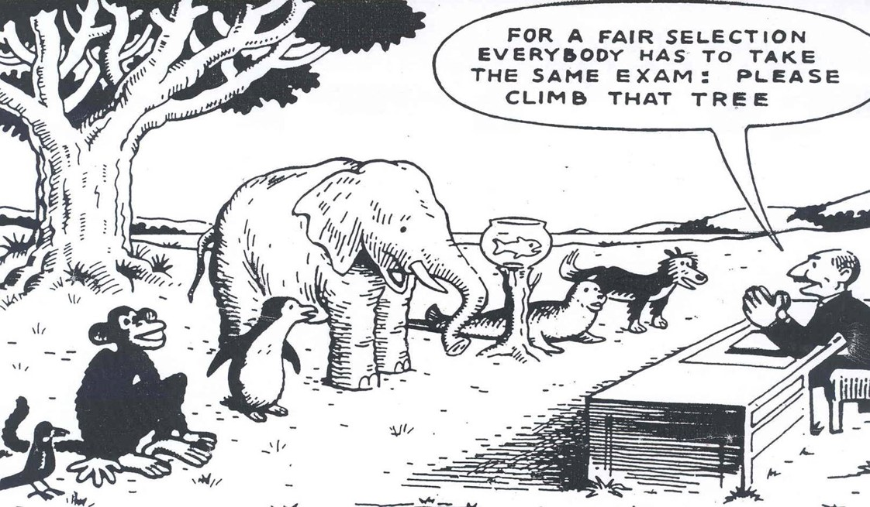

**Marxists** disagree with functionalists, arguing society is not a meritocracy. They believe those born into the working class (poorer members of society) have less chance of succeeding in life. They believe the upper class (the rich) have a much higher chance of succeeding and dominate the top positions in society.

**Feminists** also disagree, arguing women have less chance of succeeding than men. They argue society is patriarchal, meaning that men have an inbuilt advantage compared to women, and that women are disadvantaged and oppressed.

Other sociologists believe people from ethnic minority backgrounds are disadvantaged, due to individual and institutional (embedded) racism.

**Is the education system fair?**

* Education policy institute found disadvantages children were 18 months behind their peers by the time they took their GCSEs
* More affluent (advantaged) students have heard 30 million more words than disadvantaged students by the time they are 5

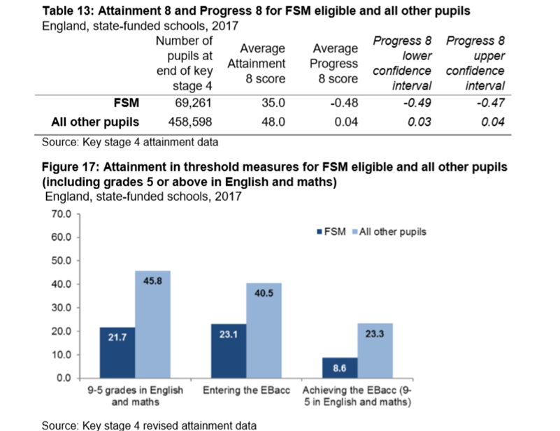

Pupils can claim Free School Meals if their household income is less than £16,000, so it is used as a measure of social class or poverty.

1. What percentage more students not on FSM achieve a grade 5 in English and Maths compared to students on FSM?
2. What does this show about which students do better in education?
3. Can you think of any reasons for this?

At school, children from different backgrounds receive very different outcomes in education. Here are some of the main reasons:

1. Material deprivation – students may lack the physical resources they need to study, like books and internet access. How might this impact their exam results?
2. Labelling – students may be labelled as lower achieving by teachers. This is when teachers attach a label to students and treat them differently. They may see working class students as less motivated, less able and less hard working. How might this impact their results?
3. Parental attitudes – parents from working class backgrounds may be less involved and less engaged in their children’s education, possibly because they had a bad experience of school themselves.

Many wealthy parents can afford to send their children to independent schools too.

Some sociologists also argue ethnic minorities have a worse experience of education, because they experience racism and institutional racism. Some also argue these inequalities are due to differences in the family structures of different ethnicities.

**Task: click on the link and watch the documentary:** [**Too Poor for Posh School?**](https://www.youtube.com/watch?v=MWYaoWPdUOI)

**Answer the following questions:**

What do the children have to do to get into private school?

What barriers do the children face?

What are the opinions/feelings of the parents?

What are the benefits of private schools?

Do you think it is fair that there are private schools?