One of the main topics in Micro Economics is the idea of Market Failure.

The text book definition of this is **“when the free market fails to allocate resources in an efficient way leading to a deadweight welfare loss”.**

I will be VERY surprised if that definition makes sense, because lets be honest… it’s a lot of waffle!

Essentially, market failure means – if there is no intervention from the government, then a good or service will be over/under produced or consumed, in a way that will negatively impact people.

<https://www.bbc.co.uk/news/health-43659124>

Above is an article about the sugar tax, please read it carefully, because it is essentially laid out like an economics essay.

|  |  |
| --- | --- |
| Good things about the sugar tax | Bad things about the sugar tax |
|  |  |
| Is it a good idea and why? | |

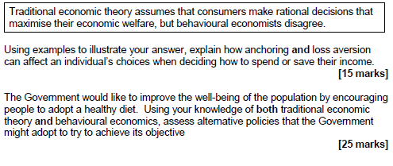

Above is a question from an A Level paper, essentially you would be using similar points to the one in the article to answer this question. **I DO NOT WANT YOU TO ANSWER THE QUESTION.**  
**Hopefully now, the idea of market failure makes sense, but I have attached some videos below I would like you to watch and make notes on.**

<https://www.youtube.com/watch?v=2HU2ZLRGyOM>

By the way, if you’re wondering who the guy is I keep posting videos of… His name is EconPlusDal.. I strongly recommend you subscribe to his Youtube Channel!