**Equality Act 2010**

The Equality Act was introduced in 2010 as a result of combining a number of older pieces of legislation-

Race Relations Act

Disability Discrimination Act

Age Discrimination Act

Sex Discrimination Act

Equal Pay Act

There are 9 protected characteristics

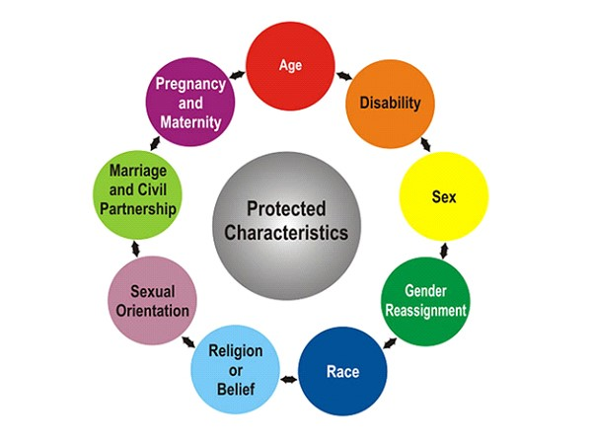

The key aspects of the Equality Act are:

* Direct and indirect discrimination on the basis of a protected characteristic is illegal.
* Discrimination in education, employment, access to goods and services and housing if prohibited.
* There is to be no harassment or victimisation.
* Reasonable adjustments must be made by employers or providers of goods and services for those with disabilities.
* Women have the right to breastfeed in public places.

**Case study 1**

“I use a wheelchair to get around and I’m finding it very hard to get a place at my local college. I want to study science and the labs are on the first floor. The college hasn’t got a lift and they say they can’t afford to have one put in just for me so I must go somewhere else. Travelling any distance is really difficult and expensive so I don’t want to go to another college.”

What protected characteristic is potentially being discriminated against?

Could this be unlawful discrimination under the Equality Act 2010?

What action could the person take?

**Case study 2**

“I was refused an apprenticeship at a local hairdresser’s because I wear the hijab and they say that all staff must wear their hair in trendy styles to impress the customers. I’m not prepared to do this as it is against my beliefs.”

What protected characteristic is potentially being discriminated against?

Could this be unlawful discrimination under the Equality Act 2010?

What action could the person take?

**Case study 3**

#### “I am an Irish Traveller. We live on a permanent site now and so we don’t move around anymore, which is great because I get to stay at the same school. But the other day I was in school and I heard a teacher making horrible comments about gypsies and travellers. They were saying our site should be shut down and we are all trouble.”

What protected characteristic is potentially being discriminated against?

Could this be unlawful discrimination under the Equality Act 2010?

What action could the person take?

**Challenge Activity:**

Is it better to have one act protecting all 9 characteristics, or is it better to have different legislation for each?