Week 5- Social Influence

This week we are going to focus on one the topic of Social Influence- this looks at why people act the way they do when they are in groups- and why we tend to change our behaviour to fit in with those around us! In particular we will study conformity and obedience but the topic in the ‘real-world’ is much bigger! I have included the specification outline for you to have a look at below.

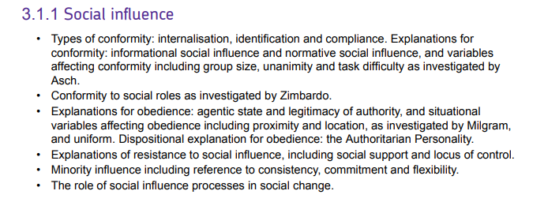

This week I would like you to research one influential piece of research from the area of social influence and write a short summary. I would like you to refer to what the experiment involves, who the researcher was, why they conducted the research and how it has influenced our understanding of social influence.

A good place to start would be with Milgram, Zimbardo or Asch as these are named on the specification. However, I would really like it if you could find some modern research (anything after 2000 would do!!)

Finally, I would like you to watch the following TEDtalk on YouTube. This explains a little bit about a famous Psychologist called Zimbardo- who is known internationally for his work into conformity to social roles. He has written a really interesting book called The Lucifer Effect which is an excellent read!

<https://www.youtube.com/watch?v=OsFEV35tWsg>

Any questions, let me know!