One of the most important aspects of any successful business; is the idea of management and leadership. Below I would like you to add your own definition of them both and also identity what you think the difference between them are.

|  |  |
| --- | --- |
| **What is a manager?** | **What is a leader?** |
| **What is the difference between the two?** | |

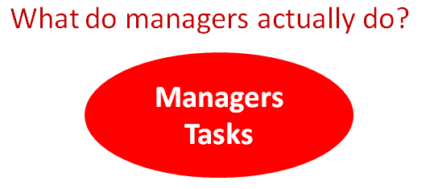

<https://www.youtube.com/watch?v=OlmmdMm52pQ>

This video above may help you answer the question.

Finally, I would like you to which management style you think **you would work best under and which style you would be as a manager.**