**Unit 14- Physiological Disorders and Their Care**

In this unit, you will learn about the signs and symptoms of physiological disorders and how they are investigated and diagnosed. You will also learn about the different types of treatment and support available for individual service users, including surgery, rehabilitation and complementary therapies.

You will create a treatment plan for a service user with a specific physiological disorder.

The knowledge gained in this unit will help you understand the treatment and support strategies involved, the contributions of different professionals and the importance of providing individualised care.

Unit 14 will be the first unit that you will study in September; this unit is assessed via a report on two selected physiological disorders and a treatment/care plan for a selected individual.

**Task**

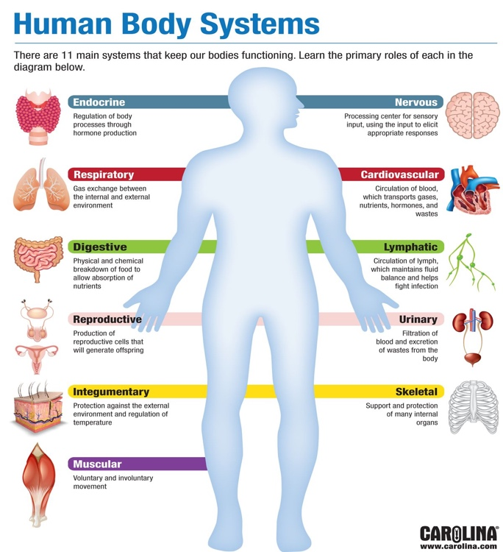

Research and write a report on one of the following medical conditions:

**Alzheimer’s Disease, Asthma, Coronary Heart Disease, Diabetes or Leukaemia**

Your report must include the following information:

* An explanation of the condition
* How the condition affects the human body systems
* The causes of the condition
* Signs of the condition
* Symptoms of the condition
* How the condition is diagnosed- what tests are done
* Treatments of the condition