**Week 2 – Attachment**

I hope that you enjoyed last week’s work and that it has given you a better understanding of what Psychology is. This week we are going to be looking at one of the topics you will study in Y12- Attachment.

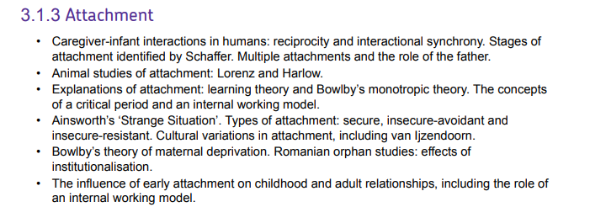Attachment is the study of how children develop relationships with parents, relatives and friends alike! All animals create unique bonds with their caregivers so they can survive the early stages of their lives. Below are the key points you will study on the specification- please feel free to research these in more detail.

For this weeks task we are going to move away from the spec slightly and look at what happens when children don’t form attachments. Will they be able to develop into healthy, happy adults or will something go very wrong? We cover this a little bit where the spec says **‘Bowlby’s theory of maternal deprivation’**. I would like you to watch the documentary below and complete the tasks that follow. You can either take a picture of your answers or type them up and upload them to SMHW. I would love to know your thoughts on the topic so let me know what you think in the comments section of SMHW.

<https://www.youtube.com/watch?v=cymZq1VblU0>

Summarise what the documentary is showing, this should be more than a paragraph but no more than a side of A4 it should include the answers to the following questions:

Did the children discussed in the documentary show differences in the way they behave?

What do you think is the most important thing a child needs in order to be raised into a ‘successful’ adult?

Do you think we can apply what we find out from feral children to ‘normal’ children? Justify your answer.

Do you think it is justified that humans carry out research on animals? Give reasons for your answer.