**Week 3- Psychopathology**

This week we are going to look at Psychopathology. Psychopathology is the scientific study of mental disorders. In particular we focus on three disorders- OCD, Depression and Phobias. When studying psychopathology we need to be mindful of those who we are studying and of those around us. 1 in 4 people in the UK will experience a mental health problem each year which are often extremely distressing to the individual. When approaching this topic (and lots of other topics in psychology) we need to show compassion and respect- you have no idea what somebody may be going through- unlike physical illnesses mental illnesses can often be difficult to spot.

Below is an outline of the spec, please feel free to research any part of it and email me any questions you have!

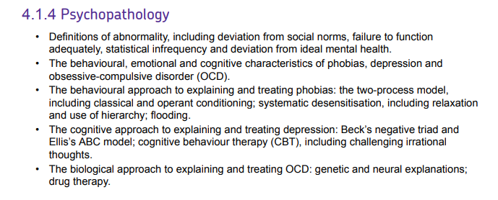

I would first like you to find the definitions and the most common treatments for the following disorders;

1. OCD

Definition: ____________________________________________________________________________________________________________________________________________________________________________________________________________________________________________________________________________________________________________

Most common treatment:

____________________________________________________________________________________________________________________________________________________________________________________________________________________________________________________________________________________________________________

1. Depression

Definition: ____________________________________________________________________________________________________________________________________________________________________________________________________________________________________________________________________________________________________________

Most common treatment:

____________________________________________________________________________________________________________________________________________________________________________________________________________________________________________________________________________________________________________

1. Phobias:

Definition: ____________________________________________________________________________________________________________________________________________________________________________________________________________________________________________________________________________________________________________

Most common treatment:

____________________________________________________________________________________________________________________________________________________________________________________________________________________________________________________________________________________________________________

For the second task I would like you to watch Nadiya Hussain’s documentary about anxiety and summarise the most important points below. I want you to include what you have learnt about anxiety in terms of how it is defined, what it is like to suffer with anxiety and what are the treatments available. Whilst we don’t specifically study anxiety it is a very powerful documentary and well worth the watch! You must watch the documentary by Friday- that’s when it is removed from BBC Iplayer!

<https://www.bbc.co.uk/iplayer/episode/m00053fy/nadiya-anxiety-and-me>