**Important Chemists and their Discoveries**

We live in an age where we are able to understand lots about chemistry already – this is due to some of the work of chemists over the past 300 years who have made some important discoveries.

Find out some information about each of these scientists and detail a short paragraph on their main contributions to chemical understanding.

Some of the chemists and their discoveries can be found here: <https://www.superprof.co.uk/blog/most-famous-chemists/>

**Inorganic Chemistry**



Name: **Antoine Lavoisier**

Nationality:

Famous for:

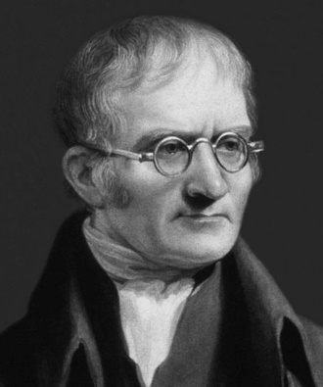

Name: **John Dalton**

Nationality:

Famous for:



Name: **Dmitri Mendeleev**

Nationality:

Famous for:



Name: **Linus Pauling**

Nationality:

Famous for:

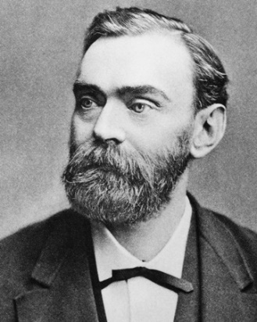

Name: **Alfred Nobel**

Nationality:

Famous for:

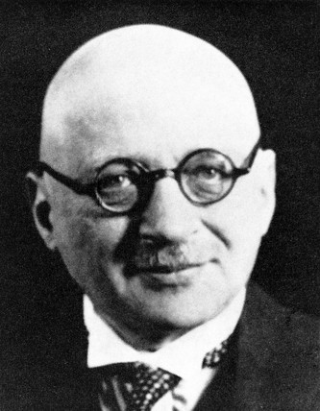

Name: **Fritz Haber**

Nationality:

Famous for:

**Physical Chemistry**



Name: **Joseph (J J) Thomson**

Nationality:

Famous for:

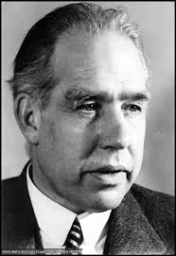

Name: **Niels Bohr**

Nationality:

Famous for:



Name: **Amadeo Avogadro**

Nationality:

Famous for:



Name: **Svante Arrhenius**

Nationality:

Famous for:

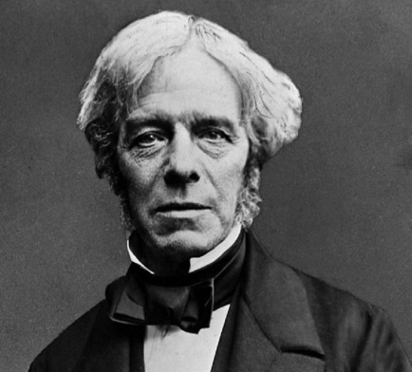

Name: **Michael Faraday**

Nationality:

Famous for:

**Organic and Biological Chemistry**

Name: **Jons Jacob Berzelius**

Nationality:

Famous for:

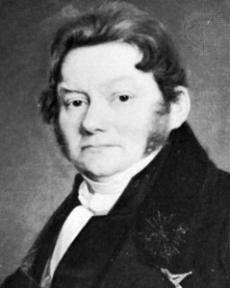

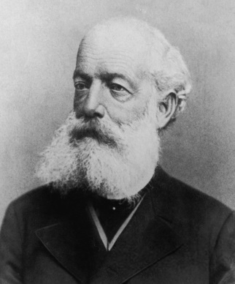

Name: **Auguste Kekule**

Nationality:

Famous for:

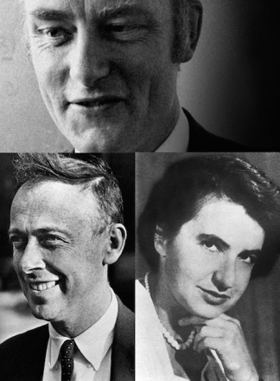

Name: **Francis Crick, James Watson and Rosalind Franklin**

Nationalities:

Famous for:

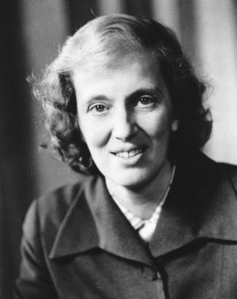

Name: **Dorothy Hodgkin**

Nationality:

Famous for:



Name: **Gertrude B. Elion**

Nationality:

Famous for: