**A Level History Year 11 Bridging the Gap**

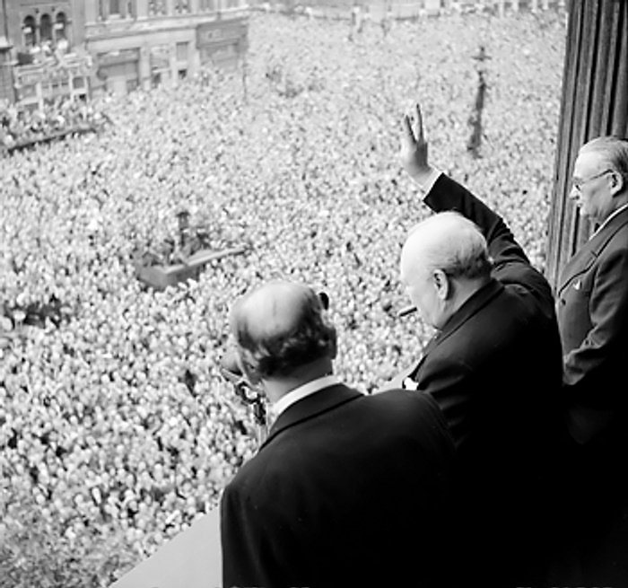

**Victory!**

**Good job too. The country’s bleedin’ exhausted!**

*Welcome, year 11! This is you first ‘Bridging the Gap’ task for A level History, which you’ve chosen to take at A level this September. The pack is designed to give you an understanding of the wider context of Britain between 1945 and 1951, ready for the course to begin in September. The pack will introduce you to some of the key issues and events in Britain ready for us to later discuss in class. You’ll soon see that a lot of the course is discussing the material and understanding how it impacts later events. The work in these packs will take a few weeks and I will be posting a new task every week.*

*It would be amazing to see your ‘Bridging the Gap’ work when it is completed.*

*You can email me on* [*wright_s@trinityhigh.com*](mailto:wright_s@trinityhigh.com) *or share via your OneDrive*

|  |  |  |  |
| --- | --- | --- | --- |
|  | **A Level course outline** | | |
|  | **1K: The Making of a Superpower: USA, 1865-1975** | **2S: The Making of Modern Britain, 1951-2007** | **Non-examined assessment**  **(Coursework)** |
| **Year 12** | 1. The Era of Reconstruction and the Gilded Age, 1865–1890 2. Populism, progressivism and imperialism, 1890–1920 | 1. The Affluent Society, 1951–1964 2. The Sixties, 1964–1970 3. The end of Post-War Consensus, 1970–1979 |  |
| **Year 13** | 1. Crisis of identity, 1920–1945 2. The Superpower, 1945–1975 | 1. The impact of Thatcherism, 1979–1987 2. Towards a new Consensus, 1987–1997 3. The Era of New Labour, 1997–2007 | The European Witchcraze, c.1560-1660  *Or an option of your choice* |

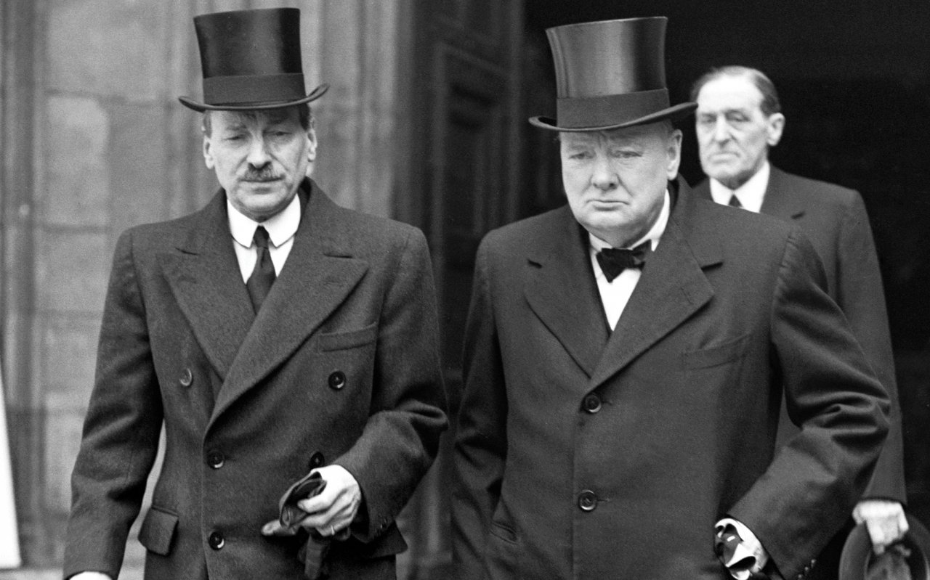

“Come then, let us go forward together with our united strength”

The two gentlemen pictured above are Clement Attlee (Left) and Winston Churchill (right). Winston Churchill was appointed leader of the Conservative Party, and therefore Prime Minister, in 1940. As Britain was still fighting a war with Nazi Germany, Churchill established a National Government which was made up of representatives of the Labour and Conservative parties, to steer the country through the wartime emergency.

Clement Attlee, the leader of the Labour Party, holding the positions of Lord Privy seal and Deputy Prime Minister, led the Labour Party between 1935 and 1955.

These two men are of great importance for placing the History Course into its context. In 1945, Churchill loses the election to Attlee, who remains Prime Minister until 1951 when Churchill again becomes Prime Minister.

Your **first task** is to create profiles for each of these men. What are their backgrounds, their politics, and their most notable events in history? You can find information from a variety of sources. These men are very well known and a quick Google search will bring up thousands of results from Wikipedia to BBC Archives to the National Archives. You can look for information wherever you want.

Your **second task** is to watch the following YouTube documentary about the 1945 election: [www.youtube.com/watch?v=SWXtbg3gUJw](http://www.youtube.com/watch?v=SWXtbg3gUJw)

You are not expected to make notes or write in detail as I want you just to absorb the context of 1945, but you may wish to consider the following questions in your watching:

* Soldiers returning from the continent in 1945 remembered the promises made to soldiers after the First World War. What promises had been made to soldiers in 1918 and why were these unfulfilled?
* What was the Tory (Conservative) plan of attack for the election?
* What issues did the Labour Party campaign on?
* What happened at Walthamstow track which suggested people were unhappy with the Conservative Party?
* Why do you think Churchill was not seen as strong on Domestic issues?
* Who was expected to win: By the Tories? By Labour? By the press?
* Why did Labour believe they had achieved ‘a mandate for change’?

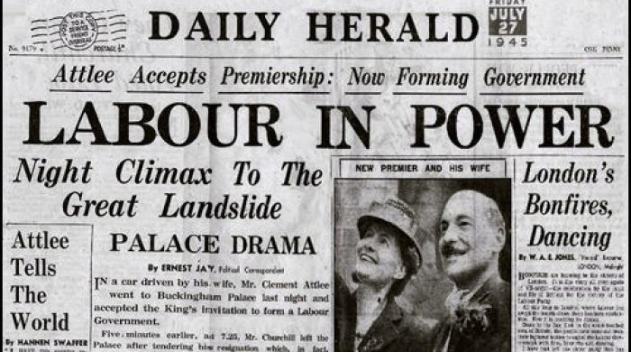

And just for an extra bit of background as those of you who know me, know that I love random bits of History:

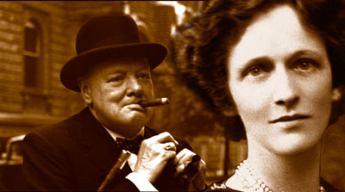

The picture of the left shows Churchill and Lady Astor, who was the first female MP to take her seat in the House of Commons. Can you find any of the insults they exchanged over the years?

*There is a reason why he didn’t seem to fit the new world order after 1945!*