**How well do you understand atoms from GCSE?**

***Properties of atoms***

Q1: Fill in this table for the relative masses of parts of the atom and their relative charges.

|  |  |  |
| --- | --- | --- |
| Name of particle | Relative mass | Relative Charge |
| Proton |  |  |
| Neutron |  |  |
| Electron |  |  |

Q2: Label the diagram.

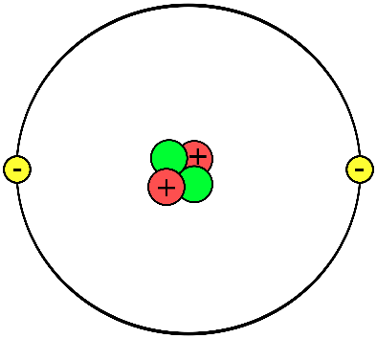

1. Where is almost all the mass in an atom?
2. Which element is represented in the diagram?

Q3. Define the following terms:

**Atomic (proton) number =**

**Mass number =**

**Isotope =**

**Relative Atomic Mass =**

Q4: Label the diagram for what each number represents in the periodic table.

|  |  |  |
| --- | --- | --- |
| **23**  Na  **11** |  |  |
|  |
|  | |
|  |  |
|  |

Q5: State the number of protons, electrons and neutrons in each of these elements.

**40** Protons: Neutrons: Electrons:

Ca

**20**

**24** Protons: Neutrons: Electrons:

Mg

**12**

**80** Protons: Neutrons: Electrons:

Br

**35**

**293** Protons: Neutrons: Electrons:

Lv

**116**

Q6: Chlorine exists as two isotopes. Calculate its *relative atomic mass* to 1 decimal place with the following information. You must show your working.

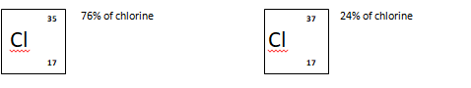

RAM (Ar) = *(mass of isotope 1 x % abundance of isotope 1) + (mass of isotope 2 x % abundance of isotope 2)*

*100*

**GCSE H Tier Question:**

This question is about atoms.

(a)     What does the number 19 represent in  ?

**(1)**

(b)     How many atoms are present in one mole of fluorine atoms?

Tick (✔) **one** box.

|  |  |
| --- | --- |
| 2.03 × 1026 |  |
| 2.06 × 1023 |  |
| 6.02 × 1023 |  |
| 6.02 × 1026 |  |

**(1)**

(c)     The plum pudding model of the atom was replaced by the nuclear model.

The nuclear model was developed after the alpha particle scattering experiment.



Compare the plum pudding model with the nuclear model of the atom.

**(4)**

(d)     An element has three isotopes.

The table shows the mass numbers and percentage of each isotope.

|  |  |  |  |
| --- | --- | --- | --- |
|  | **Isotope 1** | **Isotope 2** | **Isotope 3** |
| Mass number | 24 | 25 | 26 |
| Percentage (%) | 78.6 | 10.1 | 11.3 |

Calculate the relative atomic mass (*A*r) of the element.

Give your answer to 3 significant figures.

Relative atomic mass = ____________________

**(2)**

**(Total 8 marks)**