Week Two: Attlee’s Britain



Attlee won in 1945 because Labour had promised a new future for Britain; one with government intervention to secure jobs, houses and healthcare. He was recognised by the public as being the man who had led Britain throughout the war in the domestic sphere (In Britain, as opposed to Churchill who led Foreign Policy).

To take a look at his government’s actions in these years and gain an understanding of the Britain of 1951, I want you to have a play on the National Archives website. The national Archives are the official archive and publisher for the UK Government, and for England and Wales. They are a wealth of material for 20th Century History and in year 12, there are 3 occasions where you will be sent to this website to research. The best bit is, you get to see the original document and a typed up transcript just in case the original is weathered.

<https://www.nationalarchives.gov.uk/education/resources/attlees-britain/?show=all#more>

Your **first task** is to visit the Archives website and you will see a range of documents relating to Britain after 1945. Read **one** of any extract related to housing and employment. What do you learn about Attlee’s Government and Britain post 1945 from the extract?

*If there are any words which are confusing to you at this point, you can either use a dictionary or utilise the skills from GCSE where you ignore the word and try to retain an overall understanding of the concept.

HOUSING: ______________________________________________________________________________________

_______________________________________________________________________________________________

_______________________________________________________________________________________________

_______________________________________________________________________________________________

_______________________________________________________________________________________________

_______________________________________________________________________________________________

EMPLOYMENT: __________________________________________________________________________________

_______________________________________________________________________________________________

_______________________________________________________________________________________________

_______________________________________________________________________________________________

_______________________________________________________________________________________________

_______________________________________________________________________________________________

The NHS demands separate attention. When we officially start the course it will become clear that the NHS was a massive vote winner …. Not for Labour in 1951, but the Conservatives!! As soon as they realised it was a popular policy and could win or lose them elections, they chose to back it in 1951. With so little difference between the parties, this became known as the era of **consensus** politics. This means a broad agreement of principles between both parties.

The NHS is also significant because on the very highest levels in the Labour Party, it caused arguments and infighting.

So let’s go back ...

In 1942 the Beveridge Report was published in the UK. The report was an immediate best seller, selling 635,000 copies as it promised to ‘undertake a survey of the existing national schemes of social insurance and allied services, including workmen's compensation, and to make recommendations.’ This was to make sure that when the Second World War was over, Britain was a place fit for returning soldiers and their families, that the people of Britain would be looked after and rewarded for their many sacrifices.

The report identified ‘5 giants’ on the road to reconstruction were Want, Disease, Ignorance, Squalor and Idleness. The public backed the proposals by a huge majority and newspapers from the *Manchester Guardian* to the *Telegraph* lauded the suggested measures as the natural culmination of the Liberal Reforms of 1911.

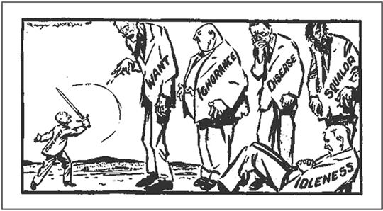

Beveridge slaying the first of the ‘five giants’

Churchill himself urged caution until the debt from the war was better known and Labour was split on how soon to push for social reform.

During the war some steps were made by the coalition government towards the Welfare State:

* 1939 – Food prices stabilised
* 1940 – Subsidised milk and fuel to mothers and to children under the age of 5
* 1940 – Free Diphtheria vaccine to be provided for children at school
* 1940 – Supplementary pensions introduced
* 1944 – Education Act (Known as Butler Act) - Every child entitled to a free school meal and there would, for the first time, be free Secondary Education for all. The 11+ was also introduced, creating a tripartite education system of grammar schools, technical schools and secondary moderns.
* 1944 – Town and Country Planning Act - Gave consideration to those areas damaged in bombing raids and enabled local authorities to clear slums

After 1945, the following steps were taken:

* 1945 – Family Allowances Act
* 1946 & 1948 - National Insurance (Industrial Injuries) Acts

<https://www.youtube.com/watch?v=nOISyKhy474>

**This clip explains to the public how the new NHS will work**

* 1946 & 1949 - National Insurance Acts
* **1946 - National Health Service Act**
* 1947 - Pensions (Increase) Act
* 1949 -Landlord and Tenant (Rent Control) Act

The NHS came into being in 1948 and the provisions said, *It shall be the duty of the Minister of Health ... to promote the establishment ... of a comprehensive health service designed to secure improvement in the physical and mental health of the people of England and Wales and the prevention, diagnosis and treatment of illness and for that purpose to provide or secure the effective provision of services ...*

The NHS was to provide free at the point of access, healthcare for all people, regardless of income or social status. In reality, some provision was made for some small charges. Aneurin (Nye) Bevan was appointed Minster of Health in Attlee’s 1945 government, and although he faced some criticisms from doctors over the formation of the NHS, he successfully presided over its inception.

However, it was not the case that the NHS was created without problems and issues. The biggest of these was cost. In 1951 Nye Bevan resigned from the cabinet in protest at the introduction of prescription charges, designed to save £25m to pay for Britain’s role in the Korean War.

Your **second task** is to read the following opinions of Attlee’s government and summarise the opinion in the box on the right. Can you also write **for** *or* **against,** depending on what you think the writer’s overall opinion of the Post War Labour government was.

|  |  |
| --- | --- |
| In large areas of policy, the Attlee government had a clear record of achievement and of competence, which acted as a platform for successive governments, Conservative and Labour, throughout the next quarter of a century. The Attlee government offered a record of sustained, if erratic, economic growth. It provided a base for the era of affluence from 1952 onwards. It was a gifted administration, one in which all welded into some kind of coherent whole. The socialist ideal still retained its validity for all these ministers, with Attlee himself anxious to reinforce it. But this ideal was combined with executive competence in most areas and a zest for power. Kenneth O Morgan, *Labour in Power* (1985) |  |
| With the election of Attlee’s Labour Government there began a sustained attempt , which lasted over thirty years, a centralised, managerial, bureaucratic, interventionist style of government. The British government soon jammed a finger in every pie. It levied high rates of tax. It planned development at every level. It managed the economy. It nationalised industries, either directly by taking ownership, or indirectly by using its powers of regulation to contain the decisions of private management in the direction the government wanted. It made available various forms of welfare for a wide range of contingencies, generally on a universal basis. And when some people preferred to rely on their own resources or on the assistance of family and friends, the Government would run advertising campaigns to persuade people of the virtue of dependence. Margaret Thatcher, *The Downing Street Years* (1993) |  |
| Why was so little achieved, so little changed, so much left intact? Why was there no real advance towards socialism? It was certainly not due to the strength of the forces of monopoly capitalism. A few shrewd blows at the start would have meant an end to their power, and the Labour Party could not merely have carried the building of a socialist Britain a very long way, but they could have given moral leadership to the whole of Europe. The government, overwhelmingly right wing in composition and outlook, accepted the capitalist status quo and never sought to alter the class structure of the nation, to attack the seats and sources of power, or even to weaken the ruling class. DN Pritt, *The Labour Government 1945-51* (1963)  **Communism** |  |

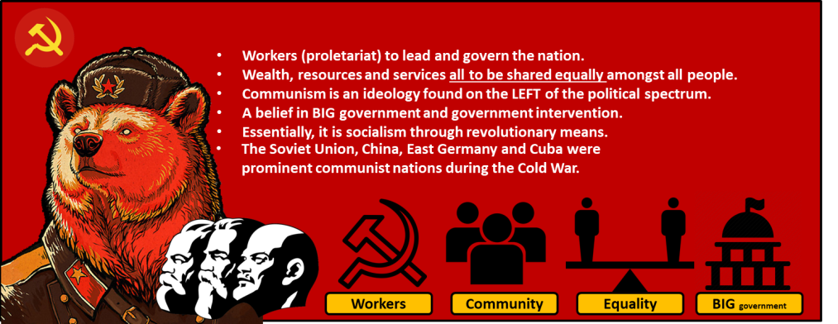

 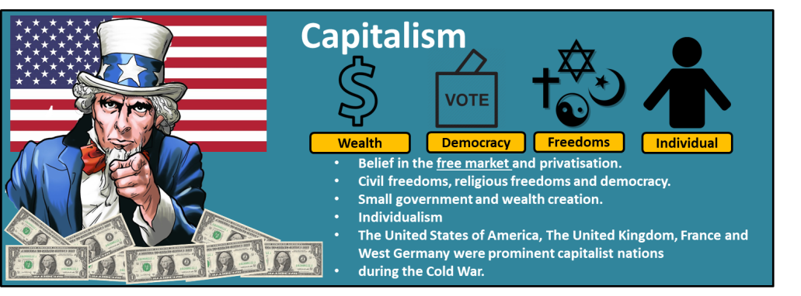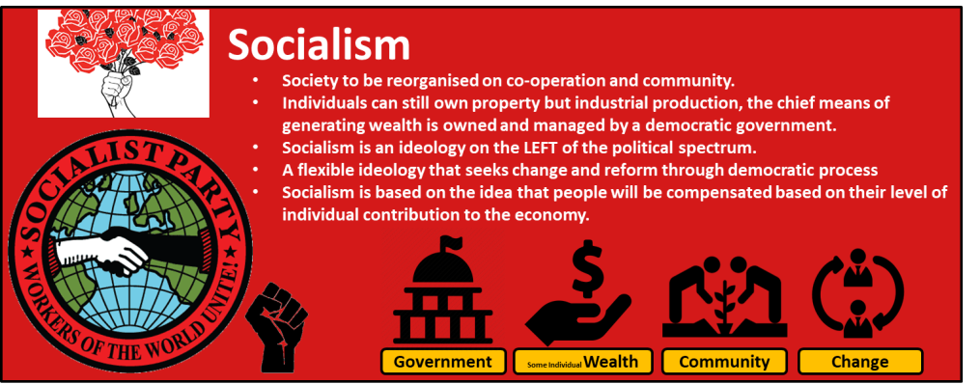

*Key ideologies overview*

*\*Mentioned in one or two places here (e.g. socialism).*

*\*Important for next 2 activities on the start of the Cold* *War*