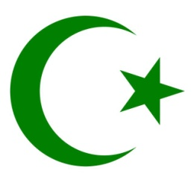***BBC documentary – ‘The Life of Muhammad’ (Part 1) – Question Sheet***

1. Who was Prophet Muhammad?
2. What do Muslims wear to Mecca? Why?
3. What did Rageh hear when he was born?
4. Where is the holiest place for Muslims?
5. What is the name of the Muslim holy pilgrimage?
6. Why do Muslims circle the Ka’ba?
7. What the different between Muhammad and Jesus?
8. What year was Muhammad born?
9. Why is Muhammad not depicted in art or as an image?
10. What is the name of Muhammad’s sayings and teachings?
11. Is there historical evidence of Muhammad’s existence?
12. What happened in Muhammad’s early years?
13. During Muhammad’s time, what did the people believe?
14. What was unusual about Muhammad’s engagement?
15. What happened to Muhammad in the mountain cave, Hira?
16. Why did Muhammad doubt this experience?
17. What was Muhammad’s duty?
18. Muslims believe that Muhammad was illiterate. What does this mean and why is this important?
19. Why is it so offensive to damage the Qur’an?
20. Why was Islam considered revolutionary at the time?
21. What did Muhammad warn against?
22. What happened to many of Muhammad’s followers?
23. What did Muhammad do next?