**NQF BTEC LEVEL 3 - SPORT**

**Unit 1: Anatomy and Physiology**

**Learning aim A – The effects of exercise and sports performance on the skeletal system**

**Activity 3**

Being flexible is really important in many sports – what sports do you think require high levels of flexibility?

***Flexibility can be defined as having an adequate range of motion in all joints in the body or the ability to move a joint fluidly through its complete range of movement.*** So we are now going to explore how joints of the upper and lower skeleton are used in sporting techniques and actions.

On the diagram of the skeleton below can you identify the joints of the upper and lower skeleton by circling them…

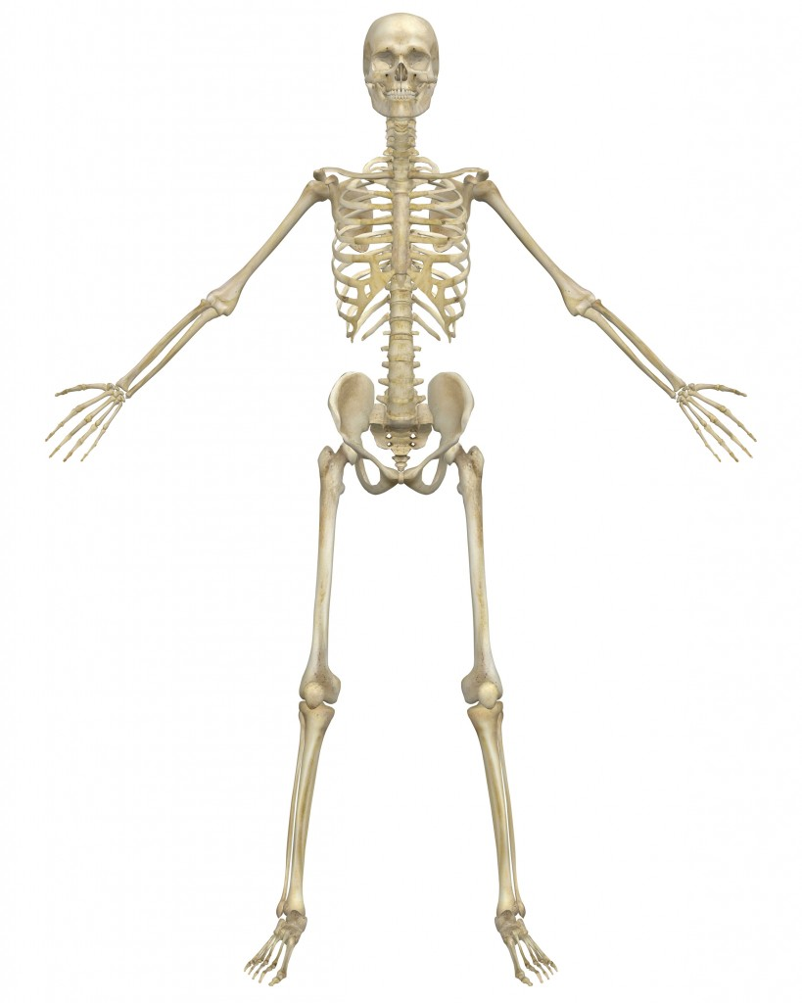

Did you circle all of the following?

* Joints of the upper skeleton; shoulder, elbow, wrist, cervical and thoracic vertebrae
* Joints of the lower skeleton; hip, knee, ankle, lumbar, sacrum, coccygeal vertebrae

Now you know where the joints are located do you know how these are classified? Can you list an example of a joint within the different classifications?

* **Fibrous joints** (fixed joints) – these joints are fixed and don’t allow any movement
* **Cartilaginous joints** (slightly moveable joints) – these joints can only move a small amount
* **Synovial joints** (freely moveable joints) – these are joints where a greater degree of movement is possible and we will be looking at these types of joints in more detail as there are numerous different types of synovial joints you need to know about, these include;
  + *Hinge*
  + *Ball and socket*
  + *Condyloid*
  + *Pivot*
  + *Saddle*
  + *Gliding*

In the spaces below take each type of synovial joint and identify; where you would find this type of joint, the bones that form this joint and the range of movement at this joint in terms of sporting actions so; flexion, extension, dorsiflexion, plantarflexion, lateral flexion, horizontal flexion, horizontal extension, hyperextension, abduction, adduction, horizontal abduction and adduction, rotation, circumduction (you may need to remind yourselves of what some of these movements are)

|  |
| --- |
| *Type of joint:*  *Where might you find this joint and the bones that form this joint?*  *What range of movement does it allow?* |
| *Type of joint:*  *Where might you find this joint and the bones that form this joint?*  *What range of movement does it allow?* |
| *Type of joint:*  *Where might you find this joint and the bones that form this joint?*  *What range of movement does it allow?* |
| *Type of joint:*  *Where might you find this joint and the bones that form this joint?*  *What range of movement does it allow?* |
| *Type of joint:*  *Where might you find this joint and the bones that form this joint?*  *What range of movement does it allow?* |
| *Type of joint:*  *Where might you find this joint and the bones that form this joint?*  *What range of movement does it allow?* |

*Hint. If you’re struggling to identify the different synovial joints have a look at the list below;*

* + *Hinge e.g. knee joint*
  + *Ball and socket e.g. hip and shoulder joint*
  + *Condyloid e.g. wrist joint*
  + *Pivot e.g. cervical vertebrae*
  + *Saddle e.g. carpo-metacarpal joint of thumb*
  + *Gliding e.g. intercarpal and intertarsal joints*

***Research task;*** investigate the structure and function of components of synovial joints and their use in sporting techniques and actions including;

* ***joint capsule***
* ***bursa***
* ***articular cartilage***
* ***synovial membrane***
* ***synovial fluid***
* ***ligaments***

Draw a diagram on the back of this page to help you making sure you label the relevant parts and make notes around the outside…