**Biological molecules (Pages 1-3, Head start to A-Level Biology)**

Create a flow diagram to identify the different types of biological molecules.  
You will need to include diagrams to show the final molecule and it should be done on an A4/A3 piece of plain paper.

The format how you present your flow chart and which questions you may want to include is up to you, some examples are given below (I expect you all to have much more detail in yours)

You must include the following molecules:

**Carbohydrates** – monosaccharides and poly saccharides

**Proteins** – primary, secondary and tertiary structure

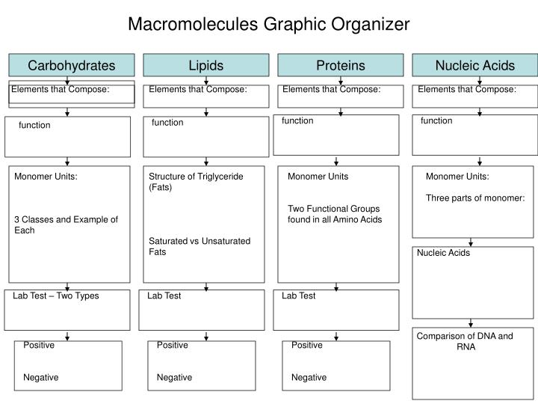**Lipids** – saturated/unsaturated

