Week Three: The Cold War background

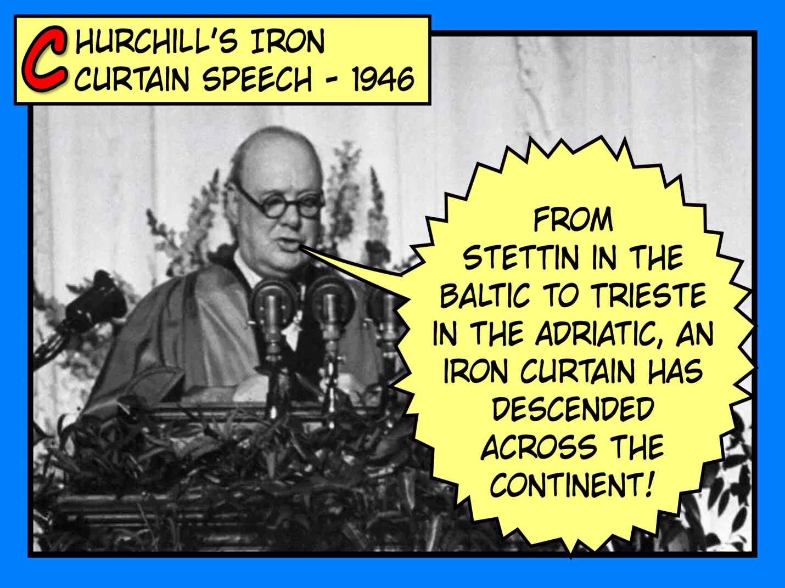

The other big piece of news from Britain in the 1950s concerned the Cold War.

Firstly, what is a Cold War? A Cold War is a war of words, propaganda and hostilities between countries that stops short of an actual armed conflict (this would be a Hot War). We use the term Cold War to refer to the relationship between the USSR (Russia and her satellite states) and the USA in the decades following the Second World War.

For the background to this, we need to first go back to Russia in 1917. When Russia entered the First World War, she was a monarchy, ruled by Tsars (pronounced *zar*). With the war going hideously for Russia, Tsar Nicholas II was overthrown in February/March 1917 and replaced by a Provisional Government. After they continued to fight the war and struggled to unite the various groups within Russia, there was a second revolution in October/November of 1917, followed by Lenin and the Bolsheviks seizing power and turning Russia into a Socialist Republic in 1918.

In 1922, Russia became known as the Soviet Union or USSR as the Russian, Transcaucasian, Ukrainian, and Byelorussian republics were united. So why is this little aside in history so important to Britain in 1951? At the end of the last piece of work, I showed you the difference between political theories, including Capitalism and Socialism. If you remember that politicians in the USA and UK tend to have made money via capitalism you can go some way to understand why they are so fearful of socialism. Socialism would mean giving up more of their wealth – and rich people don’t often like to give money away!

In the USA in particular, they were very fearful of socialism and communism (achieving socialism through revolutionary means). In the 1920s in America there was a mass hysteria called the Red Scare that shows how terrified America was of Communism. This clip shows a summary of the Red Scare:

[www.youtube.com/watch?v=OdbClUYYaOU](http://www.youtube.com/watch?v=OdbClUYYaOU)

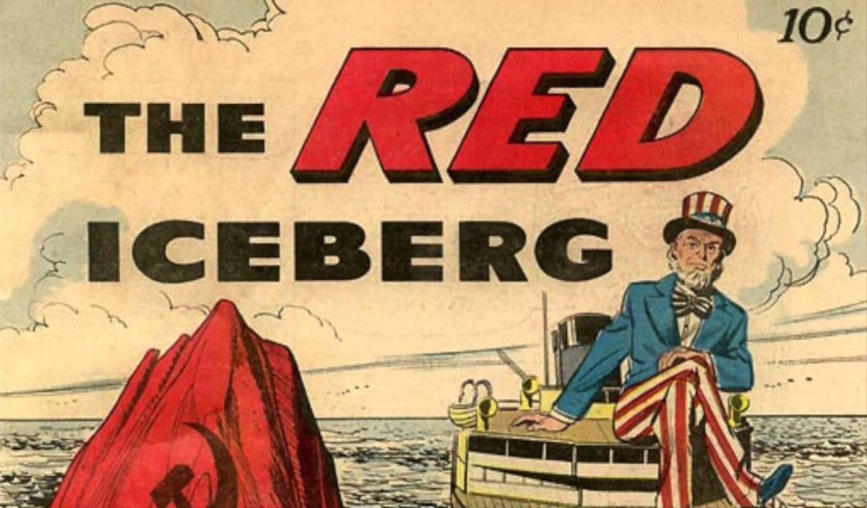

Lenin died in 1924 and was replaced by Stalin as leader of the USSR. Stalin was leader of the USSR from 1924 until his death in 1953.

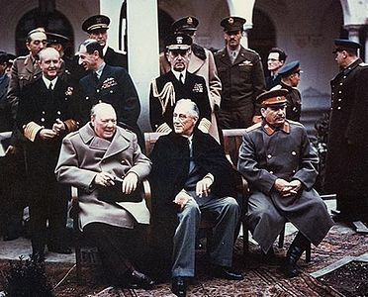

This picture was taken February 1945 at Yalta.

On the left you can see Churchill, in the middle is Roosevelt and on the right is Stalin.

This conference was probably the last time all three leaders met and were able to work together. The aim was to make plans for the end of the war and decide on what happened to Germany after it was defeated.

It is worth noting that the men only worked together because they had a common enemy (Nazi Germany), it isn’t that they were suddenly friends!

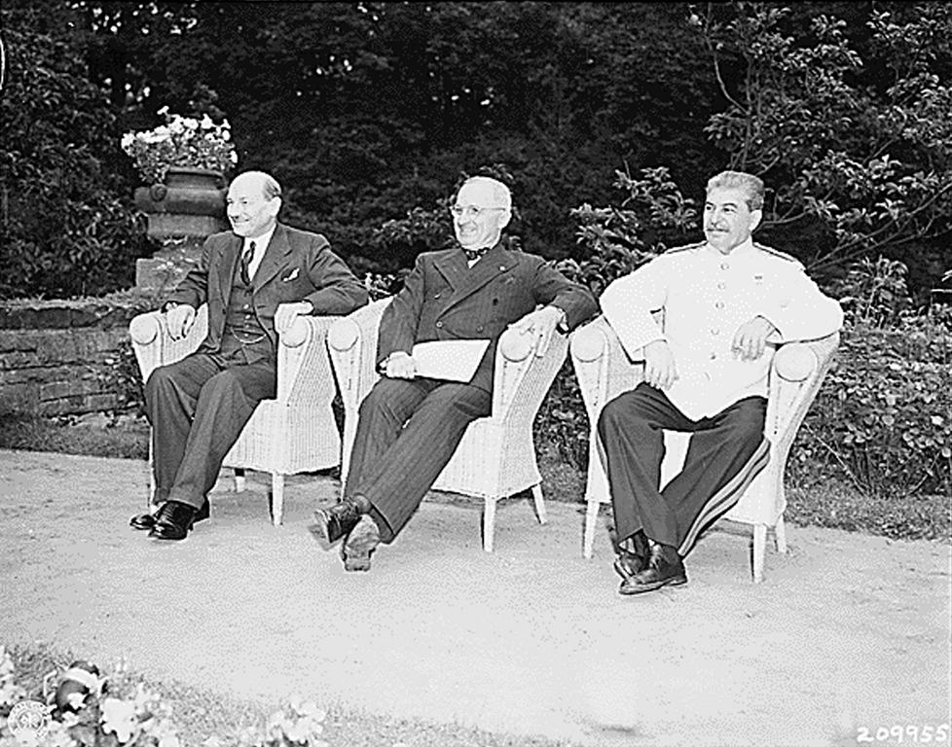

This second picture was taken August 1945 at Potsdam.

On the left you can see Attlee, in the middle is Truman and on the right is Stalin.

This conference was to decide Germany’s fate now the war was officially over and Hitler was dead. You can see that Attlee has replaced Churchill after his election win of 1945 and Roosevelt died in April 1945 and was replaced by Truman.

By this point, the relationship between the three men was already strained.

At the same time, there was the beginning of a second Red Scare in America where Senator McCarthy presided over investigations and enquiries into American’s suspected of communist sympathies. There people were often ‘blacklisted’ meaning they were unable to find employment.

**Your first task:** The Atom Bomb was dropped on Hiroshima and Nagasaki by the USA in 1945. Despite the wartime conferences to discuss the end of the war, Truman chose not to tell Stalin about the new weapon at America’s disposal. Can you research and find the answers to the following 2 questions: Why did the USA not tell Stalin and what was Stalin’s reaction upon hearing about the bomb?

_______________________________________________________________________________________________

_______________________________________________________________________________________________

_______________________________________________________________________________________________

_______________________________________________________________________________________________

_______________________________________________________________________________________________

_______________________________________________________________________________________________

_______________________________________________________________________________________________

_______________________________________________________________________________________________

_______________________________________________________________________________________________

_______________________________________________________________________________________________

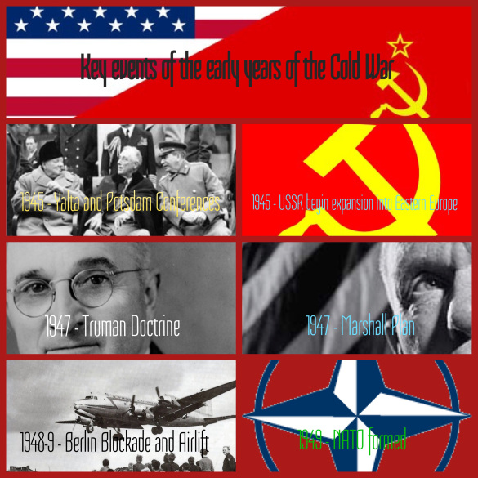

**Your second task** is to produce a quick summary of all of the events in the above graphic.

This BBC Bitesize revision page is the best place to start.

[www.bbc.co.uk/bitesize/guides/z3h9mnb/revision/1](http://www.bbc.co.uk/bitesize/guides/z3h9mnb/revision/1)

|  |  |
| --- | --- |
| 1945 Yalta and Potsdam Conferences: |  |
| 1945 USSR begin expansion into Eastern Europe: |  |
| 1947 Truman Doctrine: |  |
| 1947 Marshall Plan: |  |
| 1948-49 Berlin Blockade and Airlift: |  |
| 1949 NATO formed: |  |