**Biology bridging work – Cell Ultrastructure**

All living organisms are made from cells.

You already know about the basic parts of cells, the membrane, the nucleus and the cytoplasm. What you might not know is that there is much more going on inside a cell.

Task 1

Label the following diagrams of animal and plant cells

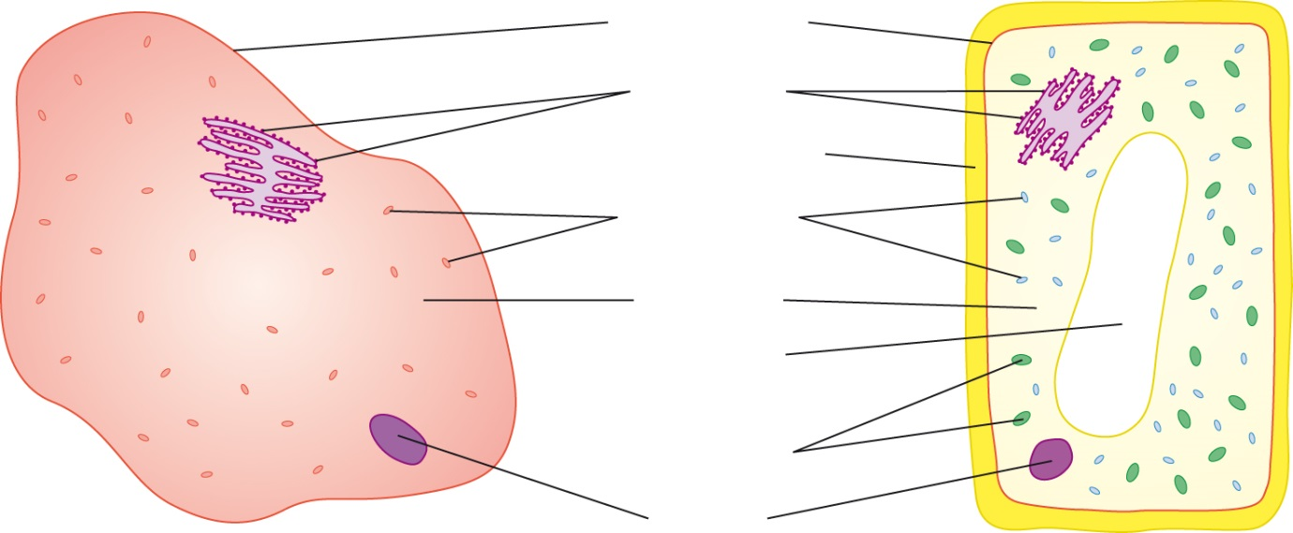



Task 2

Bacterial and yeast cells are different to plant and animal cells.

Research the structure bacterial and yeast cells.

Draw a labelled diagram of each and write a paragraph for each describing what each part does.

Task 3

Animal and plant cells can be described as eukaryotic cells.

They contain many structures that we cannot see with light microscopes.

The list below names some of those structures.

You should write a report that explains the function of each of these structures.

You should also draw a clear diagram of an animal cell with all of these structures included.

|  |  |
| --- | --- |
| **Structures to research** | |
| Nucleus | Nucleolus |
| Ribosome | Rough Endoplasmic Reticulum |
| Smooth Endoplasmic Reticulum | Mitochondria |
| Vesicles | Lysosomes |
| Golgi body | Cytoskeleton |