**Animal and Plant cells (Page 6, Head start to A-Level Biology)**

I would like you to build upon the work I set on Monday. Today I would like you to sketch an animal and plant cell, which should be hand drawn. Each diagram should fill one side of A4, clearly labelled and drawn with care. I would like the following labelled in your cells

1. Cell wall
2. Cell surface membrane
3. Nucleus
4. 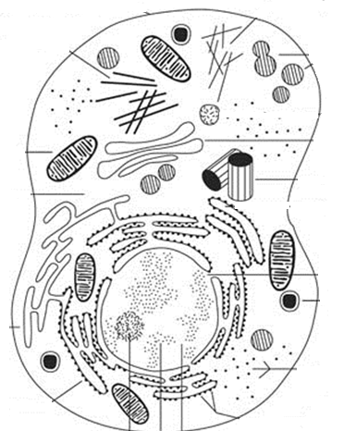Nucleolus
5. Rough ER
6. Smooth ER
7. Golgi apparatus
8. Mitochondria
9. Chloroplasts
10. Ribosomes
11. Vacuole
12. Cilia
13. Lysosomes
14. Vesicle
15. Centriole
16. Flagellum