**Sociology Transition Work**

**Week 5**

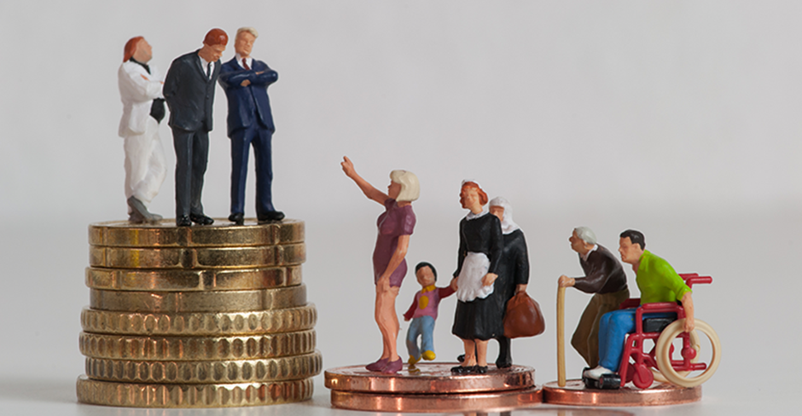

**Key questions in sociology: is modern British society fair?**

* Is the education system fair?
* Is the family fair?
* Is the criminal justice system fair?

Is There Gender Equality?

Gender equality is not only a fundamental human right, but a necessary foundation for a peaceful, prosperous and sustainable world.

There has been progress over the last decades: More girls are going to school, fewer girls are forced into early marriage, more women are serving in parliament and positions of leadership, and laws are being reformed to advance gender equality.

Despite these gains, many challenges remain: discriminatory laws and social norms remain pervasive, women continue to be underrepresented at all levels of political leadership, and 1 in 5 women and girls between the ages of 15 and 49 report experiencing physical or sexual violence by an intimate partner within a 12-month period.

Everyday, women and girls around the world face violence and discrimination. 1 in 3 women will experience physical or sexual violence in their lifetime, regardless of age, background or country, and every country in the world has laws that treat women and girls as second-class citizens. Sexual exploitation, violence, harmful cultural practices and systemic inequalities violate their human rights and prevent them from reaching their potential.

This kind of inequality is bad for everyone, not just for women: research shows that where women and girls are treated unfairly, there is more societal conflict and less economic stability.

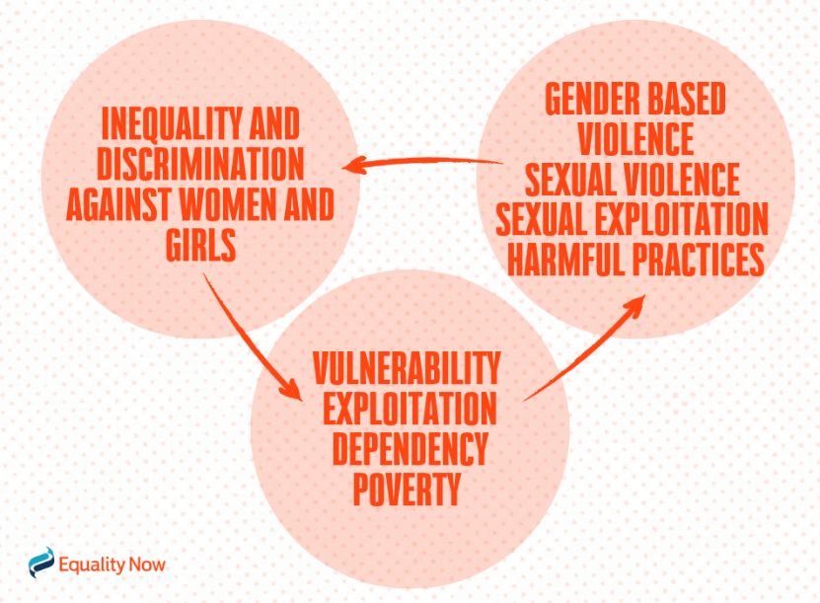

|  |
| --- |
| **Task 1: watch the video and first identify some examples of gender inequality and secondly, explain why Yasmeen Hasan (the woman in the video) says we need gender equality**  [**https://www.youtube.com/watch?v=VRsU5GpjbC8&feature=youtu.be**](https://www.youtube.com/watch?v=VRsU5GpjbC8&feature=youtu.be) |

**Task 2: watch the documentary ‘What stands in the way of women being equal to men? BBC News’. There is gender inequality in lots of areas of society for example at home, within the family, in work, education etc. Fill in the table giving examples of gender inequality in different areas of society** <https://www.youtube.com/watch?v=ayj9EVc2ZLI>

|  |  |
| --- | --- |
| **Area of society** | **Examples of inequality** |
| **Education** |  |
| **Work/ employment** |  |
| **Family/ home** |  |
| **Outside/ leisure (on the street/ doing attending sports/ public transport etc.)** |  |
| **Other examples of gender inequality** |  |