**Fractional Distillation and Cracking Review Sheet**

1. **Complete the passage below by choosing the correct answers.**

During refining, compounds in the oil are separated into groups called **fuels/fractions**.

Each fraction contains a mix of compounds with **a similar number/the same number** of

carbon atoms. Fractional distillation separates the fractions based on **their colour/their   
boiling point**. The longer chain hydrocarbons have **lower/high** boiling points

and are collected towards the **bottom/top** of the fractionating column.

1. **Here is a diagram of a fractionating column where different length hydrocarbons are collected at various temperatures inside the column. Find out some uses of the different fraction that are collected.**

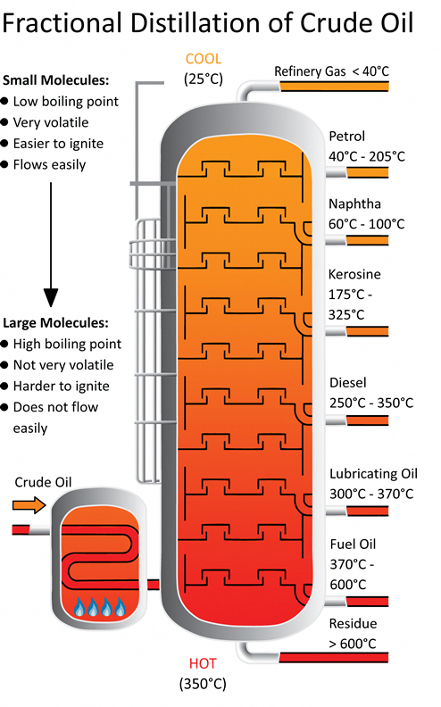

**Fractions and their Uses:**

**Refinery Gases:**

**Petrol:**

**Naphtha:**

**Kerosene:**

**Diesel:**

**Lubricating Oil:**

**Fuel Oil:**

**Residue/Bitumen:**

1. **Complete the following passage.**

In general, the ………………… the hydrocarbon chain, then the higher the boiling point of the compound. This is because the intermolecular forces between large molecules are ………………. than the intermolecular forces between small molecules. More ……………….. is needed to break the forces between large molecules, and so the boiling point is higher.

**4. Are the following statements true or false? Read each statement and then write down whether it is true or false in the column next to it.**

|  |  |
| --- | --- |
|  | **true or false?** |
| Hydrocarbons contain hydrogen, oxygen and carbon atoms. |  |
| Alkanes are saturated compounds. |  |
| Compounds that are saturated have single carbon-carbon bonds. |  |
| Catalytic cracking is an example of a thermal decomposition reaction. |  |
| Bromine water can be used to test for unsaturation. |  |
| Alkenes have the general formula CnH2n+2. |  |

**5. What are the products of *catalytic* cracking?**

………………………………………………………………………………………………………………………………………………………………………………………………………………………………………………………………………………………………………………………………………………

**6. What conditions are required for catalytic cracking?**

………………………………………………………………………………………………………………………………………………………………………………………………………………………………………………………………………………………………………………………………………………

**7. a) Write a word and symbol equation for the cracking of decane (C10H22) into pentane, ethene and propene.**

**b) What do you notice about the products that are made?**

**8. a) What are the general formulae for alkanes and alkenes?**

alkanes

alkenes

**b) What do alkenes contain that alkanes do not have?**

**9. On a separate sheet, give the displayed formula, structural and skeletal formula and for each hydrocarbon. An example using propane is provided below for you to consider.**

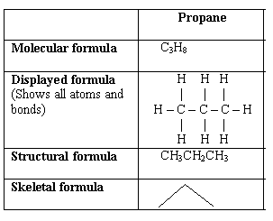

**a) ethane (C2H6)**

**b) pentane (C5H12)**

**c) nonane (C9H20)**

**d) ethene (C2H4)**

**e) propene (C3H6)**