**Exchange and Transport**

Organisms need to exchange substances selectively with their environment and this takes place at exchange surfaces. Factors such as size or metabolic rate affect the requirements of organisms and this gives rise to adaptations such as specialised exchange surfaces and mass transport systems. Substances are exchanged by passive or active transport across exchange surfaces. The structure of the plasma membrane enables control of the passage of substances into and out of cells

**Take a look at the following link:**

<https://www.youtube.com/watch?v=dPKvHrD1eS4>

**Task:**

Complete the sentences using words and phrases from the list. You may use each word or phrase once, more than once, or not at all.

**Active transport Co transport Facilitated diffusion Osmosis Simple diffusion**

Oxygen and carbon dioxide move between alveoli and capillaries by……………………….. In plants, water vapour is lost during gas exchange by ……………………… from the air spaces in the leaf to the atmosphere. The cells lining the human ileum take in glucose and sodium ions by………………………… and the glucose passes into capillaries by…………………………

**(4 marks)**

**Use the diagram below to explain how inspiration (breathing in) and expiration (breathing out) occurs.**

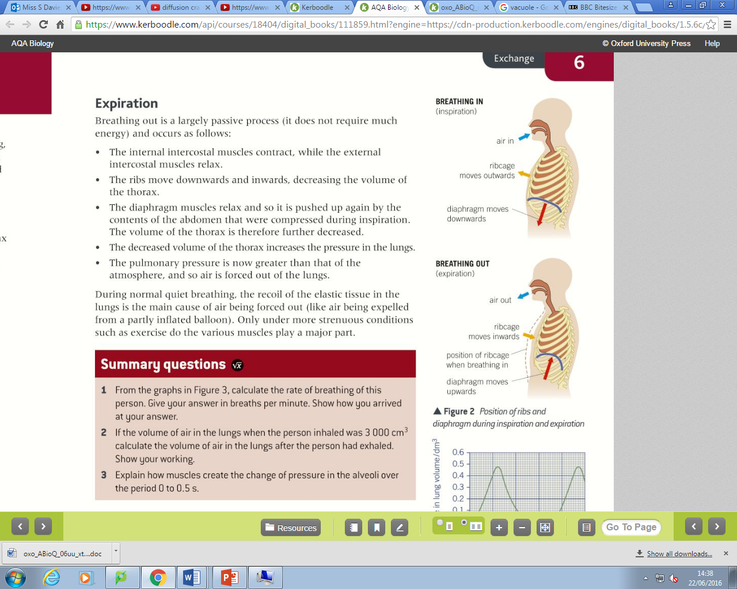

**Inspiration**

**Expiration**