**THE HEART**

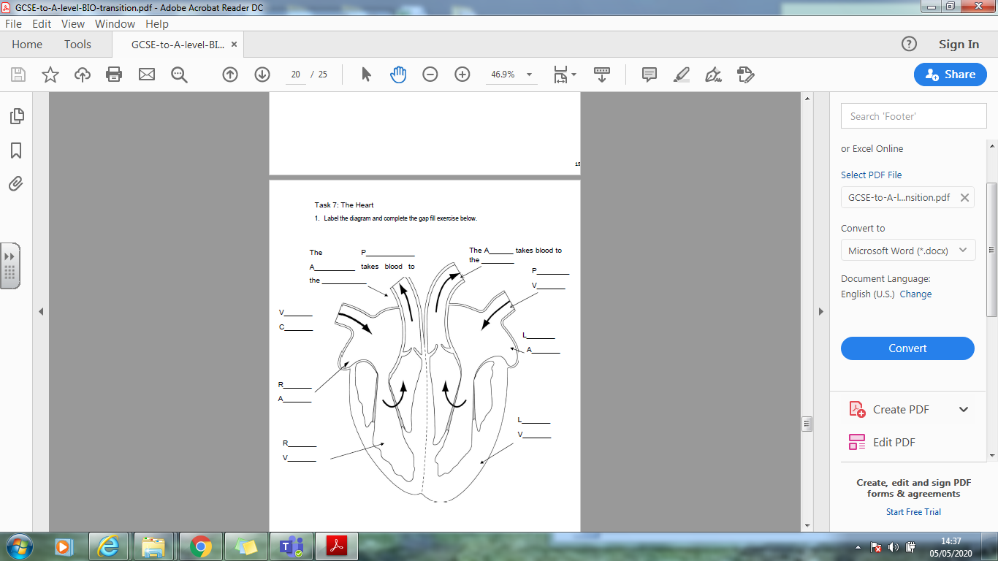

The heart is made out of ____________ Muscle.It is a double _________ that squeezes the blood around the ________ and to

the ________. The _________ sidepumps blood to the lungs to

pick up ______________. The _________ side pumps blood around the rest of the body.

3. Find out another term that is used for a heart attack

4. Which side of the heart is thicker and why?

5. Name the artery that only supplies the heart?

6. Name 3 blood vessels

7. Which blood vessel contains valves?

8. What are the functions of valves?

9. What causes heart disease?