Dear Year 12s, Transition Week 6

This week we want you to look at one of your 20 named poems that you have to study from the poetry collection called Poems of the Decade.

Read the poem ‘Chainsaw Versus the Pampas Grass’ by Simon Armitage two or three times. Then answer the questions. Keep you written notes with you in a folder ready for the start of Year 12.

Mr Cornick and Ms Parker.

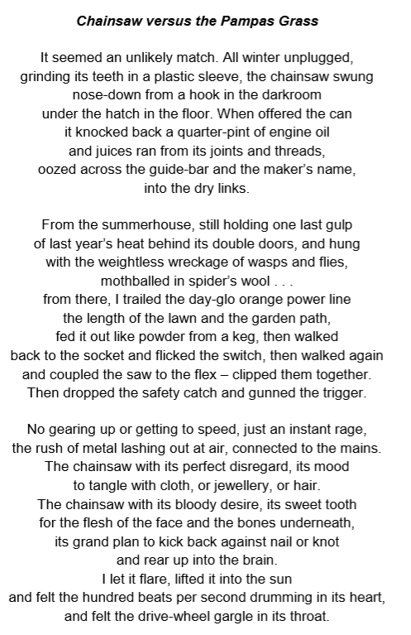

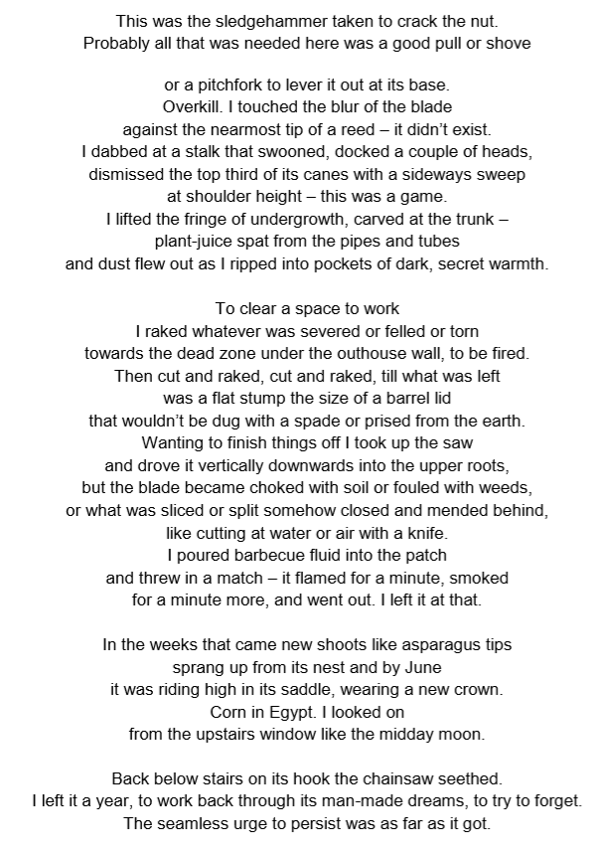

1. How does Armitage describe the chainsaw? Pick out what you think are the most interesting words or phrases. Explain how these words or phrases affect your response to the chainsaw.
2. With reference to these two pictures and the wording of the title, which of these two objects might win in a fight, in your opinion? Are you surprised by the ending of the poem?

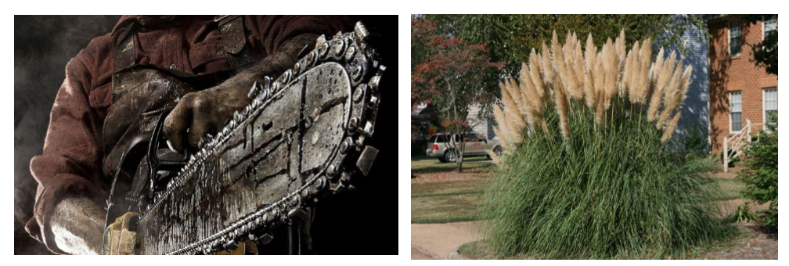

1. How does Armitage describe the pampas grass? Again, select what you think are the most interesting words or phrases and explain their effect.
2. How does the narrator approach the removal of the pampas grass? How easy does he think it will be? Find evidence in quotations to support what you say.
3. At what point in the poem does it become clear that the pampas grass is not going to be so easily defeated?
4. Make a list of the oppositions in the poem.

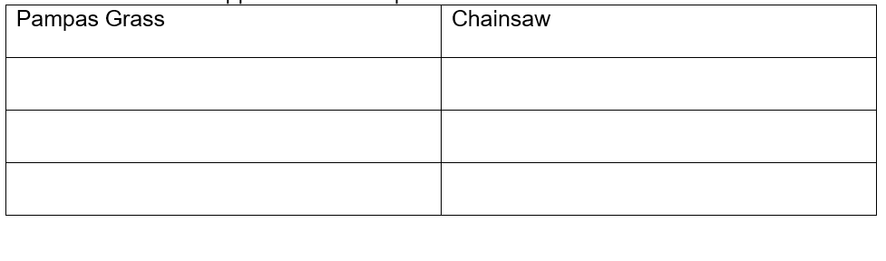 7. How do you think that Simon Armitage has used the form of the poem (stanza pattern, length of lines etc) to support his ideas?

1. What do these oppositions suggest might be some of the underlying meanings of the poem? Do you think he is using symbolism? Is this a poem purely about gardening or can it be interpreted in any other ways?