|  |
| --- |
| 17. Describing Experiments |
|

***Variables*** *– Which variables will you keep the same and which will you change?*

***Instruments*** *– What measuring instruments will you use and how will you take the measurements?*

***Range*** *– Give specific values for the range and intervals you will use. Make sure your range is large with small intervals.*

***Analyse*** *– State any equations you will use and what graph you will plot including the axes.*

***Accuracy*** *– State ways you are being accurate with your measuring instruments.*

***Reliability*** *– State “Repeat and average” to improve reliability*

*Using the steps above, describe how to carry out the following experiments below:*

e.g.

Water is placed in a plastic tray, one end it raised, dropped and the speed of the water wave is measured. A student suggests that the speed of the wave depends on the height of the water in the tray. How could you prove this?

Change the depth of water by filling the tray to different heights. The height of the water will be measured by placing a ruler into the tray. Depths from 1.0 to 5.0 cm, at 1.0 cm intervals should be used.

The tray should be lifted to the same height each time and dropped without pushing it down. The height the tray is lifted to should also be measured with a ruler that is vertical using a set square.

When the tray hits the table, the time should be measured for the wave to pass end to end 4 times, then divided by 4 to make the reading more accurate to reduce reaction time. The time should be measured using a stopwatch.

The length of the tray should be measured using a ruler, overhead and measured at eye level for accuracy.

The equation speed = distance / time should be used to calculate the speed of the wave.

Repeat each height and average to improve reliability.

Plot a graph of speed (y axis) vs depth of water (x axis) to see if there is a relationship between the two

variables.

**Question. A student suggests that if an egg was dropped from different heights the area of splatter would increase as the height increases but only until a certain point. How could you investigate this?**

|  |  |
| --- | --- |
| AS Physics | 18. Appendix 2- It’s all Greek |
| Skills |

You are expected to know most of these letters. We often use the upper and lower case letters so learn both.

The letters we will not use at A level are zeta, chi, psi, iota, kappa, xi, omicron.

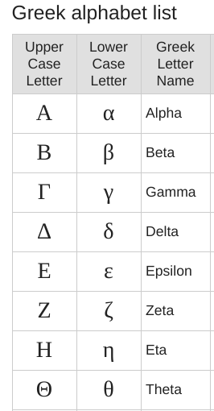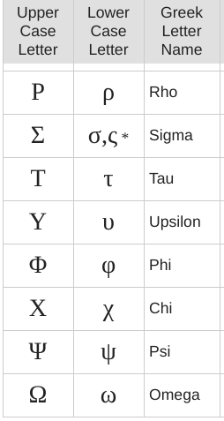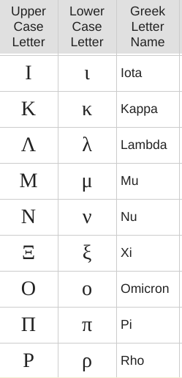

Note.

The second lower case symbol for sigma is used at the end of Greek words and not in our equations.

TASK. Write out the Greek letters that you have used in physics and mathematics and give an example of their use

e.g Rho used to represent density in a formula.

Can you find other letter you have not used yet? If you can write them out.