**Chemical Practical Work – New Pieces of Equipment**

Here are some examples of new pieces of equipment you will see at A-level.

Write a sentence to describe how each piece of equipment works – you might it helpful to watch videos so you can see how they are actually used (b-f).

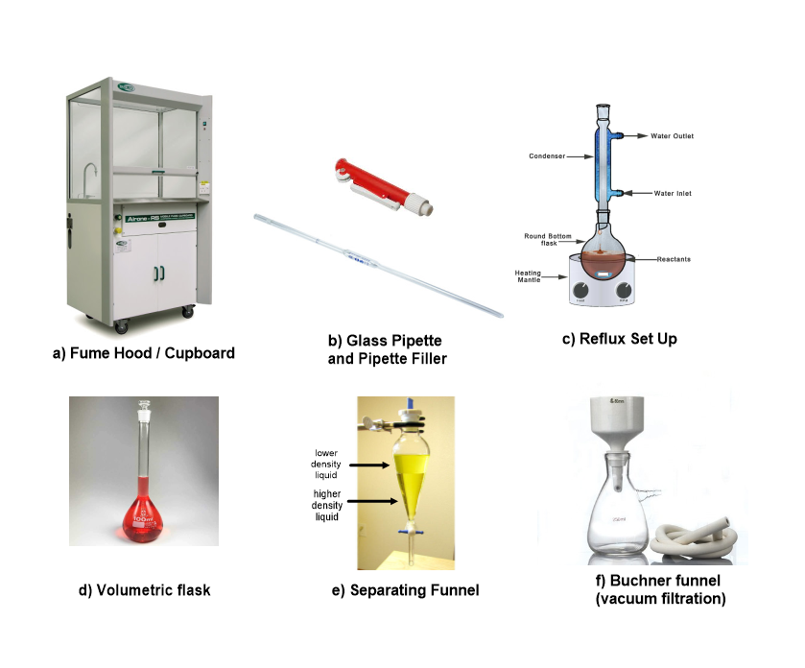

**a) Fume Hood**

**a) Fume Hood**

**b) Glass Pipette**

**c) Reflux Set Up (e.g. oxidising alcohols)**

**d) Volumetric Flask**

**e) Separating Funnel**

**f) Vacuum Filtration**