Week Nine: About you

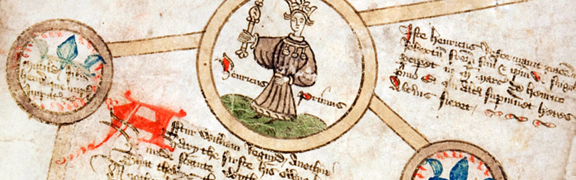

On this final week of the transition work, I have decided to offer you a bit of information about myself, as Head of History, and find out a bit more about you and why you have picked such an amazing subject at A Level!

Why I picked History at A Level:

Originally my A Level options were Maths, Physics and Electronics. During the Summer at the end of year 11 I realised that as a student who didn’t actually enjoy Maths, I had essentially picked Maths, Maths and Maths at A Level! So I switched and decided to do options I enjoyed. No thought went into a job I may do, or a university course. It was about a passion for me and History was the first subject that went down. I honestly think the main reason was that History always made me feel a bit like a detective. Looking for evidence, deciding if it was relevant or not, and trying to find a reason or a motive.

Why have you picked History at A Level?

My favourite periods of History:

I have always tried to study different periods of History and learn as much as I can. At A Level, I could pick the Modern History course or Early Modern. I knew nothing about the Tudors so I went with the latter option. Loved it! As a detective, the History puzzle always seems a bit harder to crack when the History is more removed. This is why I get a tad defensive when people are horrid to Henry VIII and tell me things like “Henry VIII was married 6 times”. He wasn’t! Legally, it was only twice! Tudors are my go-to History period. But other eras interest me too. Russian History has always grabbed my attention, especially the run up to 1917 and I have a vague plan to do a Masters one day where the focus will be a comparison of the Communist systems in Russia/Soviet Union and China.

What is your favourite period of History and why?

My favourite ways of studying history:

You name it, I love it! My family hate me for it because we can’t do anything without me aiming to teach them! TV programmes, reading, articles, visits etc. My best friend lives in Vietnam and sends me stuff she finds at markets so when she next comes home, I have some Vietnam War medals coming to me!

Unfortunately, I am not so good with historical movies. If you’ve been taught by me, you’ll know we never watched the Mary Queen of Scots film that was recently released. The biggest reason (although there are others!) is that Elizabeth and Mary meet in the film and they never, ever met in real life. I have a similar dislike for films like U571 which US studios turned into an American breakthrough! During lockdown I have also got through a large list of History books, my favourite being Frank Dikötter’s ‘Tragedy of Liberation’ which is a history of the Chinese Revolution.

What are your favourite ways of studying history?

Thank you for letting me know a bit about you! Look forward to seeing you soon! *Ms Wright*