**Q1.**

The diagram below shows a ripple tank that a student used to investigate water waves.

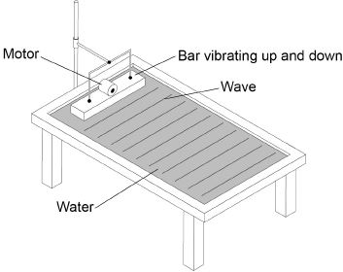

(a)  The student adjusted the speed of the motor so that the bar hit the water more times each second.

What happened to the frequency of the waves produced?

Tick **one** box.

|  |  |
| --- | --- |
| Decreased |  |
| Did not change |  |
| Increased |  |

**(1)**

(b)  Describe how the frequency of the water waves in the ripple tank can be measured.

___________________________________________________________________

___________________________________________________________________

___________________________________________________________________

___________________________________________________________________

**(2)**

(c)  The student measured the frequency of the water waves as 5 hertz.

Calculate the period of the water waves.

Use the equation:



Choose the unit.

|  |  |  |
| --- | --- | --- |
| **metres** | **metres / second** | **seconds** |

___________________________________________________________________

___________________________________________________________________

___________________________________________________________________

___________________________________________________________________

Period = ____________________ Unit = ____________________

**(3)**

**(Total 6 marks)**

**Q2.**

(a)     Which one of the following is not an electromagnetic wave?

Tick **one** box.

|  |  |
| --- | --- |
| Gamma rays |  |
| Sound |  |
| Ultraviolet |  |
| X-rays |  |

**(1)**

(b)     What type of electromagnetic wave do our eyes detect?

___________________________________________________________________

**(1)**

(c)     What is a practical use for infrared waves?

Tick **one** box.

|  |  |
| --- | --- |
| Cooking food |  |
| Energy efficient lamps |  |
| Medical imaging |  |
| Satellite communications |  |

**(1)**

Scientists have detected radio waves emitted from a distant galaxy.

Some of the radio waves from the distant galaxy have a frequency of 1 200 000 000 hertz.

(d)     Which is the same as 1 200 000 000 hertz?

Tick **one** box.

|  |  |
| --- | --- |
| 1.2 gigahertz |  |
| 1.2 kilohertz |  |
| 1.2 megahertz |  |
| 1.2 millihertz |  |

**(1)**

(e)     Radio waves travel through space at 300 000 kilometres per second (km/s).

How is 300 000 km/s converted to metres per second (m/s)?

Tick **one** box.

|  |  |
| --- | --- |
| 300 000 ÷ 1000 = 300 m/s |  |
| 300 000 × 1000 = 300 000 000 m/s |  |
| 300 000 + 1000 = 301 000 m/s |  |
| 300 000 – 1000 = 299 000 m/s |  |

**(1)**

(f)      Write the equation which links frequency, wavelength and wave speed.

___________________________________________________________________

**(1)**

(g)     Calculate the wavelength of the radio waves emitted from the distant galaxy.

Give your answer in metres.

___________________________________________________________________

___________________________________________________________________

___________________________________________________________________

wavelength = ____________________ m

**(3)**

**(Total 9 marks)**

**Q3.**

Small water waves are created in a ripple tank by a wooden bar. The wooden bar vibrates up and down hitting the surface of the water.

The figure below shows a cross-section of the ripple tank and water.

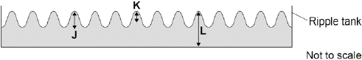

(a)     Which letter shows the amplitude of a water wave?

|  |  |
| --- | --- |
| Tick **one** box. |  |
| **J** |  |
| **K** |  |
| **L** |  |

**(1)**

(b)     The speed of the wooden bar is changed so that the bar hits the water fewer times each second.

What happens to the frequency of the waves produced?

|  |  |
| --- | --- |
| Tick **one** box. |  |
| Increases |  |
| Does not change |  |
| Decreases |  |

**(1)**

(c)     Describe how the wavelength of the water waves in a ripple tank can be measured accurately.

___________________________________________________________________

___________________________________________________________________

___________________________________________________________________

___________________________________________________________________

___________________________________________________________________

**(2)**

(d)     The speed of a wave is calculated using the following equation.

wave speed = frequency × wavelength

The water waves in a ripple tank have a wavelength of 1.2 cm and a frequency of 18.5 Hz.

How does the speed of these water waves compare to the typical speed of a person walking?

___________________________________________________________________

___________________________________________________________________

___________________________________________________________________

___________________________________________________________________

___________________________________________________________________

___________________________________________________________________

**(4)**

**(Total 8 marks)**

**Q4. The figure below shows two ways in which a wave can travel along a slinky spring.**

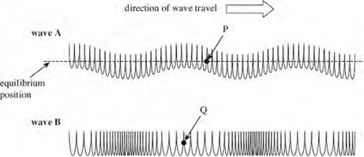

(a) State and explain which wave is longitudinal.

.........................................................................................................................................................

.........................................................................................................................................................**(2)**

(b) On the figure above,

(i) clearly indicate and label the wavelength of **wave B (1)**

(ii) use arrows to show the direction in which the points **P** and **Q** are about to move as

each wave moves to the right. **(2)**

(c) Electromagnetic waves are similar in nature to **wave A**.

Explain why it is important to correctly align the aerial of a TV in order to receive the

strongest signal.

........................................................................................................................

........................................................................................................................

........................................................................................................................

........................................................................................................................ **(2)**

**(Total 7 marks)**

**Q5.** (a) The diagram below represents a progressive wave travelling from left to stretched string.

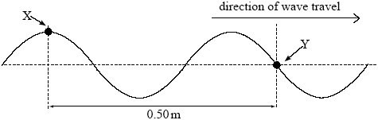

(i) Calculate the wavelength of the wave.

answer ................................... m **(1)**

(ii) The frequency of the wave is 22 Hz. Calculate the speed of the wave.

answer............................m s–1 **(2)**