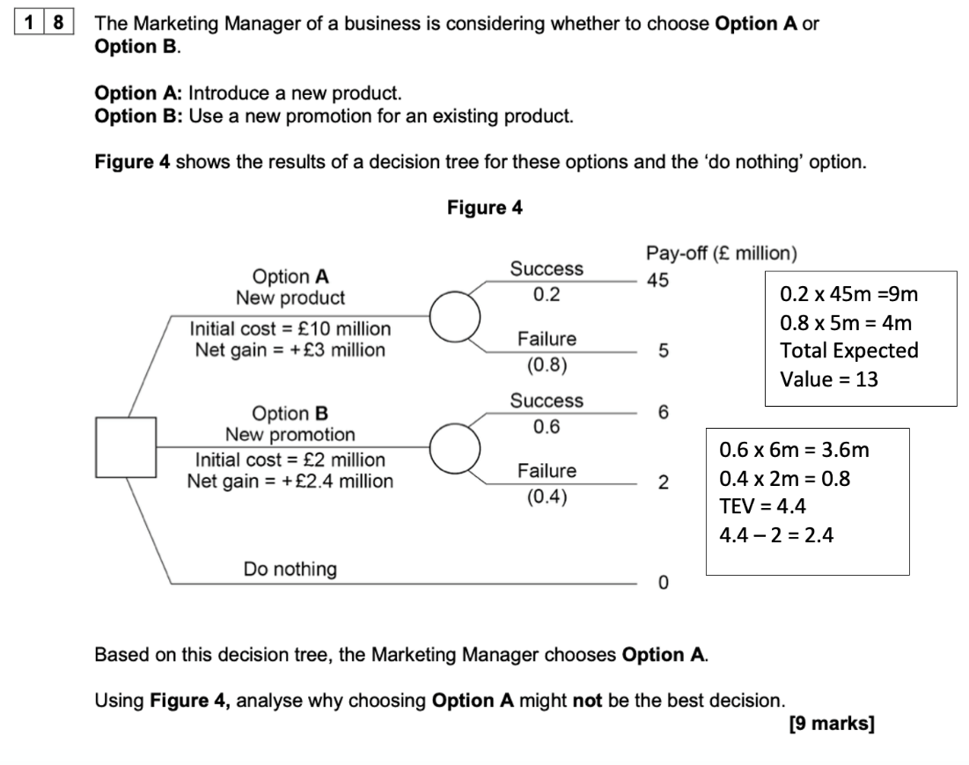
This is a question from the AQA specification but has its relevance.
State and explain two reasons why option A may not be the best decision.
Reason 1
Reason 2

