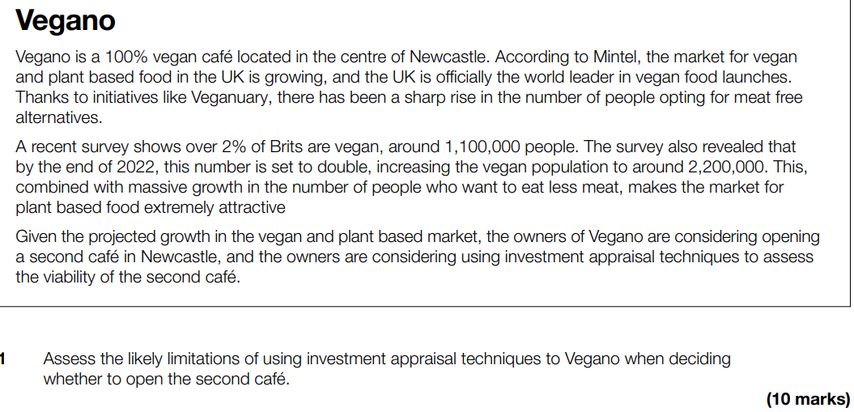
Investment appraisal is the process of evaluating an investment to see if it is worthwhile, there are three methods, payback, ARR and NPV. The limitation of Vegano using investment appraisal to make a decision about their new cafe is that the data they are using from MINTEL is a projection, this means that there is not guaranteed to be an increase to 2,200,000 vegans by the end of 2022 which may damage the accuracy of their investment appraisal. Additionally, methods such as NPV require a discount factor which can vary given external factors, it may be very expensive for vegano to generate an NPV as they would need expertise to predict the correct discount factor. Additionally as they are in a growing market it would be difficult to predict sales for the future.

HOWEVER, it could be argued that investment appraisal techniques such as payback would be helpful to vegano as it would enable them to find out how long it would take them to make their money back on building the new cafe. Additionally, using NPV would allow them to fully understand the value of future cashflows, meaning they can see if the new cafe would be financially viable. Finally, if they had a target return in mind for the cafe, ARR would enable them to see if their ideas are likely to return the income they expect.
In conclusion, it can be said that although investment appraisal techniques are liable to mistakes and incorrect data, they would be a helpful tool to vegano as they already understand the market in Newcastle due to their existing store, this is likely to make the data more accurate than if they were building a new café elsewhere.

