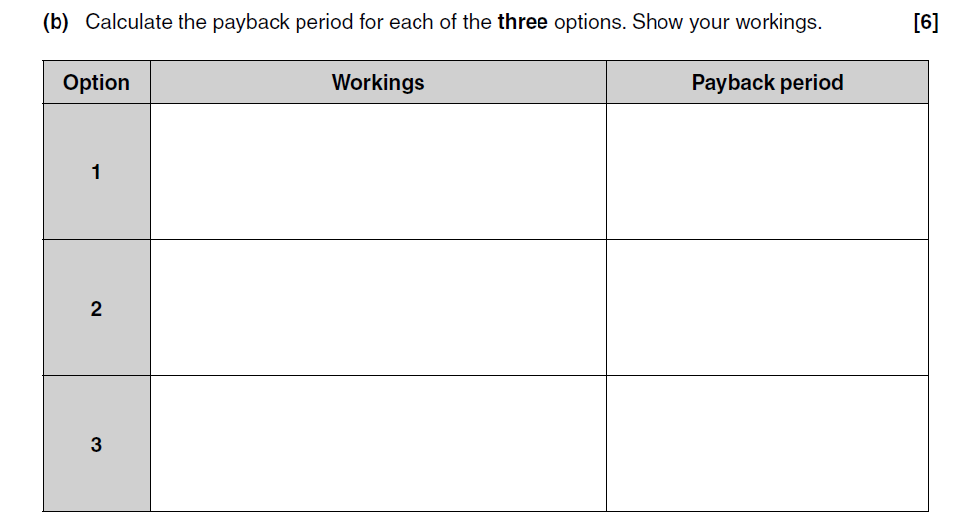
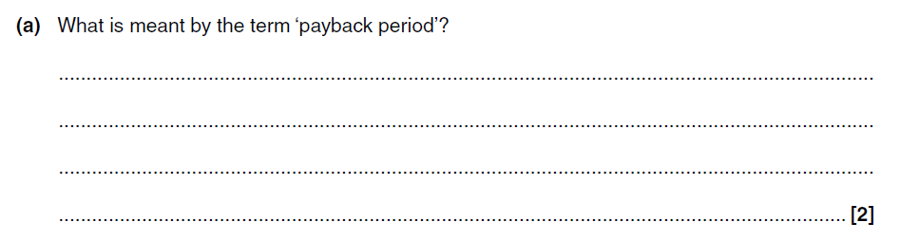
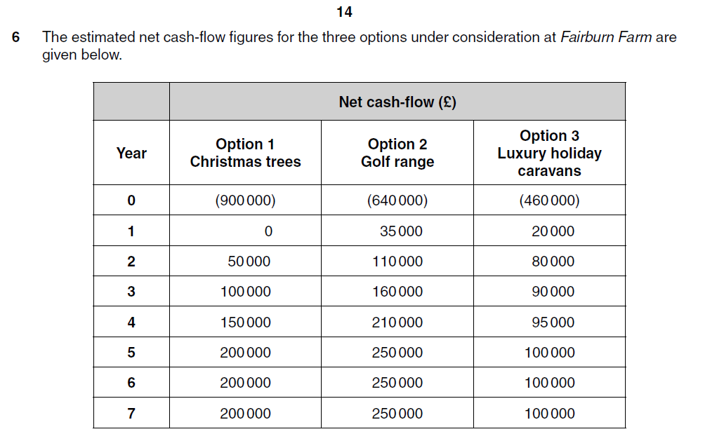
Making Investment Decisions
Investment Appraisal Previous Exam Questions
- What is meant by the term ‘investment appraisal’?
____________________________________________________________________________________________________________________________________________________________________________________________________________________________________________________________________________________________________________________________
Table 1 Appraising an investment opportunity
 | Opportunity 1 | Opportunity 2
Initial cost | £350,000 | £600,000
Inflows:
Year 1 | £50,000 | £300,000
Year 2 | £200,000 | £250,000
Year 3 | £100,000 | £150,000
Year 4 | £100,000 | £140,000
Year 5 | £100,000 | £130,000
Discount factor: 1, 0.91, 0.83, 0.75, 0.68, 0.62
- Calculate payback for each of the two opportunities given in Table 1.
Payback: __________________________________________________________________________________________________________________________________________________________________________________________________________________________________________________________________________________________________________________________________________________________________________________________________________________________________________________________________________________________

