Sociology Transition Work
Week 2

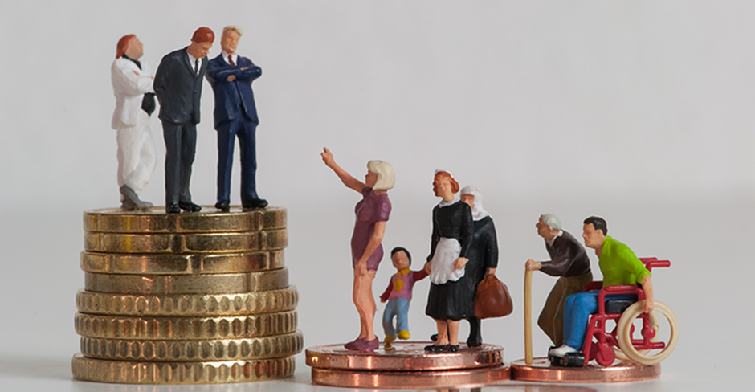

Key questions in sociology: is modern British society fair?
- Is the education system fair?
- Is the family fair?
- Is the criminal justice system fair?

Children and Poverty
Is it fair that Britain is one of the richest countries in the world but the number of children in poverty is predicted to rise by 1 million in the next five years?
Watch this documentary by Professor Green about children living in poverty in the UK.
https://www.youtube.com/watch?v=PopPlAXcWDE
As you are watching it make some notes and answer the following questions.

Explain some of the emotional effects of being evicted from your home?

Explain some of the reasons that children live in poverty?

How do the children feel about living in poverty?

