Week 6 – Psychology Transition Work – Approaches web quest
This week we are going to focus on the approaches to psychology. Although psychologists have a common goal of wanting to explain human behaviour, they often have differing views about how this should be done. Psychology is a relatively new science and has experienced many paradigm shifts. A paradigm is a ‘school of thought’ so a common way in which scientists view a behaviour. A paradigm shift is when a common way of explaining human behaviour is replaced with new ideas about how behaviours are learnt. Psychology has experiences many paradigm shifts and we now refer to them as the approaches to psychology. In total you need to know 6 approaches. I have copied the spec below.
This week I would like you to do some investigation work on the internet to find out a little bit about these approaches.
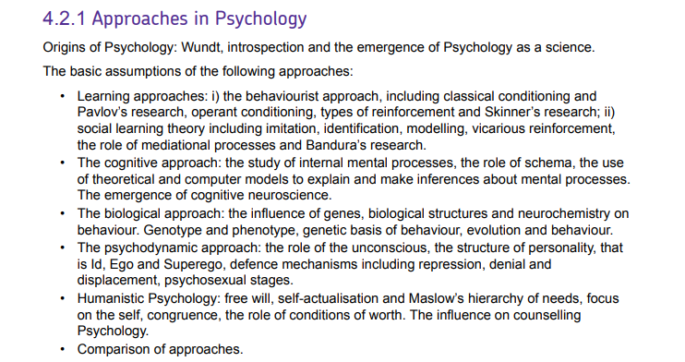

I would like you to research and answer the following questions/tasks.
- Put in chronological order the 6 approaches, with approximate dates that they were the predominant school of thought in psychology
- Name one key assumption from each approach (how do they assume human behaviour is formed)
- Name a key researcher and what they are ‘famous’ for from each approach
- Find one or two facts that interest you from each approach.
Recommended websites;
https://www.tutor2u.net/psychology
https://www.simplypsychology.org/

